ABSTRACT

In an era marked by dynamic security challenges, the demand for advanced surveillanc systems capable of adaptive and intelligent responses has increased rapidly. This research offers an innovative approach to transform surveillance techniques by combining modern robotics and artificial intelligence (AI). By utilizing deep learning techniques, our system enhances efficiency and efficacy by adding autonomous decision-making capabilities to traditional surveillance mechanisms. A key innovation of our project lies in the integration of remote-control functionalities, facilitated by advanced robotic platforms. Through seamless integration with AI algorithms, these robots can autonomously navigate and conduct surveillance tasks in complex and dynamic environments.
With the use of deep learning and artificial intelligence, our surveillance robot project welcomes a new era in security systems. These robots, remotely controlled and packed with advanced features, with intruder detection, they swiftly identify unauthorized individuals, strengthening security. This project also has a robotic arm which enable autonomous object manipulation, enhancing their versatility in various scenarios. Furthermore, including metal detection and license plate recognition enhances their surveillance capabilities, enabling quick vehicle identification and complete security checks. Temperature and humidity monitoring in real-time guarantees quick reactions to environmental changes, enhancing security measures even further.
Moreover, our approach makes use of the connection between human knowledge and machine intelligence to allow remote operators to intervene and provide direction when needed. To validate the effectiveness of our approach, we conducted extensive simulations and real-world experiments in diverse surveillance scenarios. Results demonstrate significant improvements in detection accuracy, response time, and overall surveillance coverage compared to traditional methods. Our system showcases scalability and adaptability, making it suitable for deployment in a wide range of security applications, including border patrol, industrial monitoring, and public safety.
In summary, our project presents an innovative viewpoint for surveillance systems, blending AI-driven intelligence with advanced robotic capabilities. By harnessing the power of deep learning and remote control, our solution represents a significant advancement in the field of security technology, promising enhanced situational awareness and proactive threat reduction in an increasingly complex, establishing new benchmarks for safety and dynamic security environment.

LIST OF CONTENT

Topic | Page No.
Certificate | ii
Declaration | iii
Acknowledgement | iv
Abstract | v
List of Figures | ix
List of Tables | x

CHAPTER 1 : (INTRODUCTION) | 1-7
1.1 INTRODUCTION | 1-2
1.2 PROBLEM STATEMENT | 2
1.3 PROJECT OBJECTIVE | 3
1.4 SCOPE | 3-4
1.5 PROJECT MANAGEMENT | 4-6
1.6 OVERVIEW AND BENEFITS | 7
1.7 ORGANIZATION OF THESIS | 7
CHAPTER 2 : (LITERATURE REVIEW) | 8-11
CHAPTER 3 : (THEORY) | 12-16
3.1 ARTIFICIAL INTELLIGENCE | 12
3.2 DEEP LEARNING | 13
3.3 INTRUDER DETECTION | 13
3.4 WEBSEVER | 13-14
3.5 INTERFACE USED | 14
3.6 RASBERRY PI | 15
3.7 BLOCK DIAGRAM | 15
3.5 CIRCUIT DIAGRAM | 16
CHAPTER 4 (SYSTEM ARCHITECTURE) | 17-35
4.1 COMPONENTS REQURIED | 17-24
4.1.1 MPU9250 | 17
4.1.2 NEO-6M GPS | 18
4.1.3 L298N MOTOR DRIVER | 18
4.1.4 ULTRASONIC SENSOR | 19
4.1.5 DHT 11 | 20
4.1.6 ROBOTIC ARM | 21
4.1.7 WEB SERVER CONTROLLED REMOTE | 22
4.1.8 RASBERRY PI 4 | 24
4.2 COMPONENT TABLE | 25
4.3 HARDWARE IMPLEMENTATION | 25-32
4.3.1 RASBERRY PI | 26
4.3.2 ULTRASONIC SENSOR (HC-SR04) | 26-27
4.3.3 NEO-6M GPS Module | 27
4.3.4 MPU9250 (IMU Sensor) | 28
4.3.5 L298N Motor Driver | 28-29
4.3.6 DHT11 | 29
4.3.7 Metal Detector Module | 29-30
4.3.8 Servos (6 for Robotic Arm) | 30-31
4.3.9 USB Camera Module | 31
4.3.10 Chassis Frame and PVC | 31-32
4.4 SOFTWARE IMPLEMENTATION | 32-35
4.5 KEY LIBRARIES | 35
CHAPTER 5 (WORKING AND OPERATION) | 36-43
5.1 WORKING | 36-39
5.1.1 FUNCTIONALITIES | 36
5.1.2 DETAILED WORKING | 36-37
5.1.3 KEY FEATURES | 37-38
5.1.4 SYSTEM WORKFLOW | 38-39
5.2 CODE | 40-42
5.3 FLOW DIAGRAM | 43
CHAPTER 6 (COST ESTIMATION) | 44-48
CHAPTER 7 (CONCLUSION AND FUTURE SCOPE) | 45-48
7.1 RESULT | 45
7.2 ADVANTAGES | 46
7.3 LIMITATION | 47
7.4 FURTHER ENHANCEMENT AND FUTURE SCOPE | 47
7.5 CONCLUSION | 47-48
REFERENCES | 49

LIST OF FIGURES

S.NO. | FIGURE NAME | PAGE NO.
1 | PROJECT MANAGEMENT | 6
2 | ARTIFICIAL INTELLIGENCE VS DEEP LEARNNG | 12
3 | BLOCK DIAGRAM | 15
4 | CIRCUIT DIAGRAM | 16
5 | MPU9250 (IMU SENSOR) | 17
6 | NEO-6M GPS | 18
7 | L298N MOTOR DRIVER | 19
8 | ULTRASONIC SENSOR (HC-SR04) | 20
9 | DHT 11 TEMPERATURE AND HUMIDITY SENSOR | 21
10 | ROBOTIC ARM | 22
11 | WEB SERVER CONTROLLED REMOTE | 23
12 | RASBERRY PI 4 | 24
13 | CODE | 40
14 | CODE | 41
15 | CODE | 42
16 | FLOW CHART | 43
17 | FINAL PROJECT | 45

LIST OF TABLES

TABLE NO. | TABLE | PAGE NO.
1 | Component required table | 25
2 | Key libraries | 35
3 | Cost estimation | 44

CHAPTER 1

INTRODUCTION

1.1 INTRODUCTION
In today's rapidly evolving security environment, traditional surveillance methods are facing alarming challenges in keeping pace with the complexities of modern threats and environments. The need for more adaptive, intelligent, and proactive surveillance solutions has led to a surge of interest in utilizing modern technologies, including artificial intelligence and advanced robotics. This convergence holds immense promise in reshaping the way surveillance operations are conducted, offering new levels of efficiency, accuracy, and autonomy. At the heart of this technological union is the integration of deep learning algorithms within advanced robotic platforms. Deep learning, a subset of AI, empowers systems to autonomously learn complex patterns and features from vast datasets, enabling them to make informed decisions in real-time. When combined with remote control capabilities, these AI-driven robotic systems become powerful tools for conducting surveillance tasks across diverse and challenging environments.
This project is to explore the field of AI-enhanced surveillance systems and advanced robotics that are controlled remotely in great length, with a specific focus on the integration of deep learning algorithms. By means of an extensive examination of the existing literature, case studies, and practical examples, our aim is to clarify the fundamental concepts, technological elements, and practical implementations of these innovative surveillance systems. Beginning with an exploration of the evolving nature of security threats and the limitations of conventional surveillance approaches, we set the stage for understanding the imperative for advanced surveillance solutions. Subsequently, we explore into the fundamental concepts of artificial intelligence, deep learning, and robotics, outlining their respective roles in enhancing surveillance capabilities.
The creation of an advanced robotic platform with a wide range of features designed for demanding surveillance applications lies in the heart of the project. Advanced intruder detection systems are among them; they can recognize the person which are the possible threat and follow possible threats on their own, reducing dangers in advance and improving situational awareness. A multipurpose robotic arm on the robotic platform is also equipped to do complex manipulation tasks, which makes it easier to retrieve or manipulate objects as needed for different types of surveillance scenarios.
In addition, the system uses accurate license plate recognition technology, which makes it possible to efficiently identify and track cars of interest, improving law enforcement and border control capacities. Additionally, the platform has sensitive metal detecting built in, which makes it possible to identify hidden weapons or contraband and improves security screening procedures. Furthermore, temperature and humidity sensors enable environmental monitoring, offering important information about the state of the environment and possible hazards. This integrated system, which makes use of deep learning algorithms, promises to revolutionize security protocols across several domains by providing security professionals with unbeatable levels of adaptability, response, and situational awareness.
We also explore the approaches used to easily combine AI and remote-control features into advanced robotic systems, highlighting the critical function deep learning algorithms play to encourage intelligent decision-making and self-governing behaviour. We illustrate various uses of AI-enabled surveillance systems across multiple security domains, such as border security, urban surveillance, and critical infrastructure protection, by looking at real-world case studies and practical implementations.
In conclusion, this project highlights how AI-driven surveillance systems can completely change the security operations landscape. These systems offer unmatched levels of situational awareness, responsiveness, and effectiveness in fighting off emerging threats by utilizing the cooperation between deep learning and robotics. The use of artificial intelligence (AI) and robotics into surveillance systems is becoming increasingly important in facilitating proactive and entirety security measures, particularly as we negotiate the complex modern security landscape.

1.2 PROBLEM STATEMENT
The idea behind our project came from the urgent need for creative and proactive security solutions in the constantly changing threats and problems of today. We set out to maximize the potential of deep learning and artificial intelligence to create a revolutionary security platform after realizing the shortcomings of traditional monitoring systems. In order to efficiently handle a variety of security challenges, the project intends to construct an advanced surveillance robot outfitted with cutting-edge technologies. Our team was inspired by the fast-developing fields of robotics and artificial intelligence and set out to construct a flexible, self-governing system that could adapt to a variety of events and environments. Modern technologies like metal detection, license plate recognition, intruder detection, robotic arm functionality, and environmental sensors that monitor temperature and humidity are all essential to our project's concept. Carefully designed to offer complete monitoring capabilities, these components guarantee timely threat identification, accurate detection, and proactive reaction to possible security lapses.
Our project is a result of our dedication to utilizing deep learning and artificial intelligence's transformational potential as well as our knowledge of these limits. Through the combination of these latest advances in technology with robotics breakthroughs, we want to revolutionize security solutions. Our background investigation explores the complexities of new threats, technology developments, and user needs, providing the groundwork for the creation of a cutting-edge surveillance platform. We started on our project with a full understanding of the problems we face and a shared aim to transform the state of monitoring and safety procedures in a variety of industries.
Motivated by a dedication to innovation and superiority, our project signifies a major advancement in security technology, ready to revolutionize the parameters of monitoring and safeguarding in the public and private domains. Our AI-powered surveillance robot, which prioritizes efficiency, adaptability, and dependability, is seen as a vital component of security infrastructure that is prepared for the future and will protect communities and assets with unmatched effectiveness.

1.3 PROJECT OBJECTIVES
The objective of our project is to develop an advanced surveillance system that harnesses the power of artificial intelligence and remote-control technology, grounded in deep learning principles. At its core, this system aims to elevate security measures by integrating state-of-the-art features into a singular, adaptable platform. Our goals encompass several key components: Firstly, we seek to implement AI-driven intruder detection algorithms, enabling the rapid and accurate identification of unauthorized individuals or suspicious activities within monitored areas. Secondly, we aim to equip the surveillance robot with a versatile robotic arm, empowering it to perform various tasks autonomously, ranging from object manipulation to assisting in emergency situations.
Additionally, we attempt to integrate license plate detection technology for efficient vehicle identification, enhancing perimeter security and access control. Furthermore, the deployment of metal detection capabilities will enable thorough security screenings, identifying concealed weapons or prohibited items. Finally, by incorporating temperature and humidity sensors, our system will enable real-time environmental monitoring, facilitating proactive responses to potential hazards. Through the achievement of these objectives, our project endeavours to establish a comprehensive and efficient surveillance solution capable of addressing diverse security challenges with precision and effectiveness.
Moreover, our project aims to not only enhance security measures but also to increase and optimize surveillance operations through the effortless integration of advanced technologies. Beyond the development of individual components, our main objective is to create an organized and scalable surveillance system that maximizes efficiency and effectiveness in threat detection and response. Our objective is to develop collaboration between license plate recognition, robotic arm capability, metal detection, ambient monitoring, and AI-driven intruder identification in order to establish a single platform that provides proactive security measures and comprehensive situational awareness. Our project aims to bring in a new era of intelligent and adaptable security solutions by redefining the norms of surveillance technology through the accomplishment of these goals.

1.4 SCOPE
The scope of our project includes the design, development, and implementation of an innovative surveillance system utilizing artificial intelligence and remote-control capabilities. Central to our scope is the integration of modern features into a unified platform, aimed at enhancing security measures across various environments and applications. At the forefront of our scope is the implementation of sophisticated intruder detection algorithms, leveraging AI to swiftly identify and respond to unauthorized individuals or suspicious activities within monitored areas. Additionally, we aim to equip the surveillance robot with a multifunctional robotic arm, enabling it to perform diverse tasks autonomously, thereby extending its utility and adaptability in real-world scenarios. In addition, our coverage encompasses the incorporation of license plate detection technology to enhance border security and access control through effective vehicle identification. In order to enable thorough security screenings and identify forbidden or concealed weapons, metal detection capabilities will also be integrated. Another essential component of our scope is real-time environmental monitoring, made possible by temperature and humidity sensors, which allows for prompt responses to any anomalies or potential threats.
Moreover, our project's scope goes beyond the simple integration of its component parts to include the surveillance system's smooth connectivity and scalability. Our goal is to create an architecture that is easily expandable and flexible enabling the system to be adjusted to changing security requirements and incorporating new technologies as they become available. Furthermore, our role involves the creation of easily navigable user interfaces and simple control systems to guarantee accessibility and convenience of use for security staff. Our goal is to develop a surveillance system that not only satisfies present security standards but also stays flexible and future-proof in the face of new dangers and technological developments by giving flexibility, scalability, and user-friendliness top priority within the project scope.
In conclusion, our project's scope includes the creation of a thorough surveillance system that not only makes use of modern technologies but also effectively and precisely handles a variety of security issues. By means of careful planning and execution, our goal is to create a flexible and dependable system that can protect a range of settings and resources.
1.5 PROJECT MANAGEMENT
Management of any project can be briefly disintegrated into several phases. Our project has been decomposed into the following phases: -
- Initiation Phase:
- Firstly, we define our project objectives, scope, and outcomes. This involves outlining the specific goals we aim to achieve, the boundaries within which our project will operate, and the observable outcomes we expect to produce. We guarantee clarity and focus throughout the project lifetime by outlining these details in advance.
- Next, we learn about the different fields of knowledge possessed by group members. Each team member's unique knowledge and experience contribute to the collective effort, encouraging innovation and collaboration.
- We simultaneously create an extensive project plan. This document, which outlines the project's objectives, schedule, financial requirements, and resource requirements, acts as a roadmap. It gives group members a precise structure and creates responsibility and transparency.
- Planning Phase:
- Firstly, we conduct a complete requirements analysis for each component of the project, such as intruder detection systems and robotic arms. This involves gathering and documenting detailed specifications, functionalities, and performance criteria to ensure that our solutions meet the desired objectives.
- Next, we create a work breakdown structure (WBS) to break down the project into smaller, manageable tasks. The WBS defines the hierarchical structure of the project, including tasks, subtasks, dependencies, and milestones. This offers a precise structure for planning and monitoring development over the course of the project.
- Simultaneously, we create a project schedule. With the help of the schedule, which describes the tasks in order, their durations, and their connections, we can efficiently manage project timeframes and resource allocation.
- Resource allocation and budgeting are critical aspects of the planning phase. We allocate human resources, expertise, and equipment required for development, testing, and implementation phases, ensuring that resources are utilized wisely to achieve project goals within financial limitations.
- Additionally, we define risk management strategies and emergency plans to minimize potential challenges and uncertainties. This involves identifying risks, evaluating their possibility and impact, and putting proactive steps in place to lessen or eliminate them.
- Execution Phase:
- Firstly, we procure the necessary hardware, software, and equipment required for development. This involves acquiring the tools and technologies essential for building and integrating the various components of our security system, including AI algorithms, robotic mechanisms, sensors, and surveillance equipment.
- Next, we proceed with the implementation of AI algorithms for intruder detection and other functionalities like license plate detection. By utilizing modern technologies, we create and implement advanced algorithms that can accurately identify and classify possible hazards instantly.
- Simultaneously, we create and incorporate the robotic arm mechanism into the surveillance robot. This includes creating and constructing a strong, flexible robotic arm that can engage with its surroundings and manipulate objects in addition to avoiding obstacles.
- Furthermore, we develop and test additional functionalities such as metal detection, humidity sensor and environmental sensors. These features enhance the capabilities of our security system, enabling it to gather valuable intelligence and respond effectively to various security threats.
- Throughout the Execution Phase, we conduct iterative testing and debugging to ensure the functionality and reliability of our system. Precise testing procedures are used to confirm the functionality of every part, find any flaws or weaknesses, and continuously improve the system for maximum robustness and performance.
- Monitoring and Control Phase:
- First, we carefully monitor the project's progress in relation to predetermined benchmarks and modify the timeline as needed. To make sure the project continues track, this involves routinely checking on the fulfilment of tasks, spotting any delays or obstacles, and actively rearranging deadlines.
- In order to guarantee plan consistency, we simultaneously keep a careful eye on budget expenditures and resource utilization. We uphold transparency and accountability by monitoring resource allocation and expenses, enabling us to make well-informed decisions that optimize resource utilization and reduce budgetary risks.
- The project team meets regularly to discuss issues and concerns in a timely manner. These sessions offer an environment for honest discussion, teamwork, and problem-solving, allowing us to spot new issues, generate ideas for improvements, and create a positive work atmosphere that promotes success.
- Throughout the project, quality assurance checks are carried out to ensure that standards and requirements are being followed. We guarantee that deliveries satisfy the necessary quality criteria, minimizing faults and guaranteeing customer satisfaction through extensive testing and inspection procedures.
- Furthermore, we employ change management methods to efficiently address scope modifications or unexpected challenges. This involves evaluating the effects of suggested modifications, weighing potential courses of action, and making the necessary adjustments while limiting delays to the project's advancement.
- Closure Phase:
- Firstly, we confirm that every project delivery services satisfies the acceptance criteria. This includes carrying out detailed inspections and evaluations to guarantee that every project component satisfies the established standards and specifications.
- Simultaneously, we validate and test the surveillance system one last time in real-world settings at the same time. To verify the system's functionality, dependability, and efficiency in carrying out its specified tasks, it must undergo extensive testing in operational settings.
- Documenting lessons learned and best practices obtained is just another crucial component of the Closure Phase. Through documenting the lessons learned from the project's achievements and setbacks, we build a knowledge base that will assist with future initiatives and enhance organizational procedures and practices.
- In addition, we create detailed project documentation. These documents offer information on system maintenance, troubleshooting, and operation, making them valuable tools for everyone involved.
- Lastly, we conduct a formal project analysis with guide to evaluate project success and identify areas for improvement. This review serves as an opportunity to reflect on the project's outcomes, assess its alignment with initial objectives, and gather feedback for future enhancements.
- Through careful completion of these tasks in the Closure Phase, we guarantee that the project ends smoothly, with all requirements fulfilled.
Throughout the project lifecycle, effective communication, collaboration, and coordination among team members and guide is most important in achieving project objectives and delivering a high-quality surveillance system.
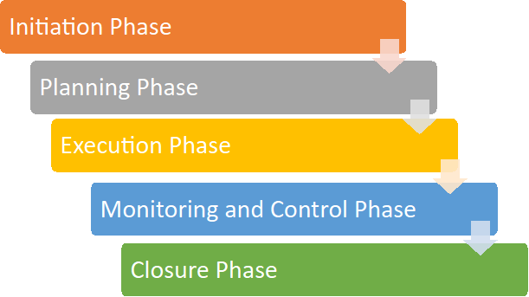

Figure 1 Model of phases in project management

1.7 OVERVIEW AND BENEFITS
The project "Surveillance with Artificial Intelligence and Remote Control Based on Deep Learning Advanced Robot" represents a groundbreaking attempt to redefine the environment of security systems. By integrating cutting-edge technologies such as artificial intelligence, deep learning, and remote-control functionalities, this project aims to develop an advanced surveillance solution with unparalleled capabilities. Central to this attempt is the creation of a multifaceted robot equipped with a suite of sophisticated features including intruder detection, robotic arm manipulation, license plate recognition, metal detection, temperature sensing, and humidity monitoring. This comprehensive approach ensures that the surveillance system is equipped to address a wide range of security challenges across diverse environments, from public spaces to industrial facilities.
The benefits of this project are various; and far-reaching. Firstly, the integration of artificial intelligence enables the surveillance system to autonomously detect and respond to potential security threats with greater speed and accuracy than traditional systems. Additionally, the inclusion of remote-control functionalities enhances the system's flexibility and adaptability, allowing operators to navigate the robot seamlessly through various environments. Furthermore, the incorporation of advanced features such as intruder detection, license plate recognition, and metal detection significantly enhance border security and access control measures. Moreover, real-time monitoring of environmental conditions including temperature and humidity enables proactive responses to potential hazards, further enhancing overall safety and security. Ultimately, this project promises to revolutionize security operations by providing organizations with a robust and intelligent surveillance solution capable of mitigating emerging threats effectively while ensuring the safety of assets and individuals.

1.8 ORGANIZATION OF THESIS
The thesis delves into the development of an integrated system for intruder detection and remote surveillance using advanced technologies such as artificial intelligence, deep learning, and Raspberry Pi. It begins with an introduction outlining the problem statement, project objectives, scope, and project management strategies. A comprehensive literature review sets the stage by examining relevant prior research. The theoretical framework explores key concepts like artificial intelligence, deep learning, intruder detection, and web server interfaces. The system architecture is meticulously detailed, encompassing the hardware components required and their implementation. The working and operation section elucidates the functionalities, detailed workings, key features, and system workflow, complemented by the relevant code and flow diagrams. A cost estimation is provided, followed by a conclusion and future scope, highlighting the results, advantages, limitations, and potential enhancements of the proposed system. This thesis offers a holistic approach towards addressing security concerns through innovative technological integration.

CHAPTER 2

LIERATURE REVIEW

The likelihood that humans will utilise robots as teammates, caretakers, assistants, and companions in their daily lives has elevated the discussion of the effects and responses of society to robotics to the centre of robotics study (1). The popular viewpoints on the correlation between technical advancement and social transformation, which represent a healthy link between robots and society, provide additional validity to a technocentric perspective on robotics. According to these narratives, society advances mostly via embracing and adjusting to the outcomes of technological innovation, with robotics development led by individuals from academia, business, and government(1). A powerful, influential machine is a robot. A robot is guided using automotive control. The robots' primary goal is to help people with their daily tasks. A robot is capable of picking up items, moving them, destroying them, and altering them as instructed(2)(3). The robot operating system is a unique, comprehensive and opensource operating system that is developed to control the robots. It is a well-known fact that robots and artificial intelligence (AI) have been working together extensively globally for a variety of reasons. Robots are increasing production, but they are also reducing job prospects. Robots work more quickly than humans do because, according to research, one robot can do the work of 70 full-time human workers. Employment possibilities decline as the use of robotics increases. But the basic advancements in robotics will only be attained by future generations after years of investment in this field(4–6). AI has a subfield called robotics. The robots' ability to develop or design a certain mission is derived from their mechanical architecture. The electrical parts that make up the robots are responsible for powering and controlling the machines. A robot's internal computer programme determines what, when, and how it completes tasks(7).
Automation and the use of industrial robots result in significant labour and product cost reductions, especially in the industries of developed nations (those with high labour costs). Thus, the cost of a manufacturing robot may be less than that of a Chinese labour. Another feature of robots is that they don't get ill, get married, have kids, go on strikes, or need yearly leave. An intelligent machine may operate in hazardous areas and can function flawlessly, constantly, and around the clock without the need for external components. It follows that its precision is higher than a human's and that it is impervious to distraction from outside factors like weariness. Intelligent systems can be guided by impartial criteria when making critical judgements, allowing for practical decision-making based on information and facts. Thus far, increases in productivity have invariably resulted in better living conditions for everybody. This also holds true for artificial intelligence. One important benefit for workers is that self-ruling frameworks may relieve them of labour-intensive tasks, such as boring, repetitive work. The same applies to common back-end tasks in the service industry: frameworks may be created to automatically collect data, move it between systems, and identify solutions to issues. Data entry can be done automatically once an interface between two systems has been configured. Intelligent machines can be built with life-saving features in addition to supporting roles; examples of such devices are inspection and medical diagnostic robots. For the greatest outcomes and to prevent any mishaps, these must be precisely created.
The field of artificial intelligence is expanding and is making inroads into the fields of business, social sector, and healthcare (8–10). An agent known as an "actor" is the foundation of robotics and artificial intelligence. An actor is a special assembly of the robot's physical structure and is regarded as a software component. The actor may operate the robot thanks to the special connection that exists between the actor and the robot's physical structure. Sensors are used by the software component to read the data. The robot chooses its next course of action and instructs its effectors to behave physically in the surroundings after finishing the reading process (7).
Raspberry Pi serves as an exceptional foundation for constructing surveillance systems due to its adaptability and cost-effectiveness. When assembling a surveillance system based on Raspberry Pi, individuals typically incorporate a variety of hardware components including camera modules, motion sensors, microphones, and storage devices. The official Raspberry Pi Camera Module or compatible USB webcams are frequently utilized for recording video footage. Moreover, microphones connected via USB or GPIO ports are utilized to capture audio, facilitating comprehensive surveillance coverage. To ensure continuous monitoring and storage of recorded data, users can leverage external storage solutions such as USB flash drives, external hard drives, or network-attached storage (NAS) systems, providing ample space for storing surveillance footage(11).
Various software options are available to cater to diverse surveillance needs. One standout choice is MotionEyeOS, a specialized Linux distribution optimized for running motion detection software on Raspberry Pi. It offers support for multiple camera setups and boasts a user-friendly web interface for easy configuration and monitoring. Additionally, the Raspberry Pi Foundation provides dedicated software libraries and utilities tailored for configuring and managing the official camera modules, enhancing adaptability and integration convenience. For more sophisticated tasks such as advanced image processing and object detection, developers often rely on OpenCV (Open-Source Computer Vision), an open-source library that empowers Raspberry Pi surveillance systems with features like facial recognition and license plate detection. By combining these hardware and software elements, users can fashion tailored Raspberry Pi surveillance solutions to meet specific needs, be it for home security, wildlife observation, or industrial monitoring applications(11).
A surveillance robot's job is to automatically identify and track motion in its surroundings. The subsystems of planning, control, and sensors have been separated out in the robot design. A robotic surveillance appliance is constructed on a mobile platform intended for security and surveillance duties. There are two operating modes for this robot: "automatic trip" and "remote eyes." This implies that it may be controlled remotely by a person acting as a watchman to act as a moving security camera or it can go on its own down an arbitrary path while identifying any irregularities in the video feed. Many military and civilian operations, such as cave-in enemy incursions and indoor hostage rescue efforts, need secret observation in very restricted areas(12). With our method, the robot can identify moving objects by utilising a wireless camera and a motion detection sensor. To guarantee reliable monitoring, the robot tracks an individual's upper body to identify unusual human behaviour. The robot is directed to the location of the events by a motion detection system, gas detector, fire sensor, or metal detector, which reduces false alarms. The robot may then use its camera to confirm the occurrences(12).
It is suggested to use a robotic surveillance system powered by a Raspberry Pi to automatically identify intruders and notify the control centre. It is suggested to use Python-OpenCV as the programming language and Raspberry Pi as the controller to create a real-time video surveillance system(13).When the identified person's face matches the database's recorded facial information, the robot advances. When there is a mismatch, the surveillance robot pauses and the relay triggers the laser gun, deactivating the intruder by firing at him(13).Classifiers that choose images as positive that is, images with faces, or negative that is, images without faces are used to detect faces. Identifying a known individual the technology keeps an eye on the surroundings and looks for any signs of human facial recognition. The system shows the identified person's name if it is known. Unknown individual identification Robot system pauses and the relay activates the laser gun to target the identified person or turns on the LED when the detected individual is unknown, i.e., the face data in the image does not match the database(13).
This system functions remotely via a web server, and all data is kept in the cloud, with only authorised individuals having access to the data when necessary. All the sensors are integrated with the Raspberry Pi board to deliver live data. Raspberry Pi handles all the system's input and output commands. The picture provided by the robotic car to the user might be tiny or huge, depending on the speed of the Raspberry Pi board and network. The Python software known as flask is utilised in Raspberry Pi to achieve real-time streaming via the web. This sort of device is more useful for monitoring an area since it adapts to unanticipated occurrences. The web page is built using HTML and includes connections in numerous directions. By clicking on these links, the user may control the robot as he sees fit. The robot's backend uses 'Flask' python packages to transfer commands from web pages to Raspberry Pi via an HTML web interface to manoeuvre the robot. The camera will produce video feed throughout the day based on changes in its surroundings, which will then be sent to the user's device over the internet. The user will have access to the video feed via the display on the user end(14).
Climate change presents significant concerns, making temperature sensing and environmental monitoring crucial. Robot automobiles fitted with temperature sensors can help monitor environmental conditions and solve climate challenges. This part will address societal concerns about climate change, air quality, and the significance of data collecting for informed decision-making. WiFireBot temperature detecting capabilities make it ideal for monitoring temperature-sensitive locations in healthcare institutions like laboratories and storage rooms. The WiFireBot offers a significant development in smart surveillance and safety technologies. Its capacity to sense temperature changes(15).
This methodology employs a revolutionary computer vision-based control system to move a robotic arm. Computer vision and artificial intelligence methods allow for the creation of a cost-effective, user-friendly, and highly efficient robotic arm. In a recent study, the authors created a fusion-based manipulation system for sensory-motor and robotic bionic arms, as well as a grasping control approach for an automated hand-eye system. The arm will move using a servo motor. The robotic arm recognises an object's geometrical shape and size using OpenCV image processing methods developed in Python(16).
As technology advances in the realm of automation, military robots are being used as soldiers in battle zones to decrease grievances and deaths. The module is comprised of an embedded system device that incorporates a central microprocessor, a metal detector. Metal detector uses electromagnetic induction to detect metallic items in its surroundings. Metal bomb detector sensors will be utilised to detect the appropriate explosives in the border area. If a bomb is discovered in the border regions, this module will trigger the buzzer to signal the bomb detection. If an explosive is detected, the controller generates an interrupt (INTF) and sends the message "bomb detected" to the remote station (18). The robot also aids in the detection of metal substances by providing latitude and longitude coordinates for the region where the metal is discovered. This bot may be used in a variety of defence applications to decrease the loss of armed troops and combat illicit operations. Another goal of this article is to create a robot automobile that can detect nearby landmines or other explosives, which are primarily built of metal. This robot detects metal components on its track and emits a buzzer sound. It also warns the nearby base station about the discovery of metal by providing the latitude and longitude coordinates of the region where the metal is discovered. This assists in saving many people's lives(19).
In this work, we created a smart spy GPS-enabled surveillance robotic system that will give a significant advantage over analogue systems while also lowering the device's cost during mass manufacturing. This document provides instructions for operating a robotic system using an internet web browser or Android applications. This is only feasible when the Raspberry Pi has an internet connection. Other sensors, such as GPS, ultrasonic sensors, and grippers, are employed to improve the performance of the smart surveillance system. GPS sensor and camera are the major interface devices for security, because the camera can deliver continuous picture or video information and GPS track the location concurrently(17).

CHAPTER 3

THEORY

3.1 AI (ARTIFICIAL INTELLIGENCE)
Artificial Intelligence (AI) is a dynamic and diverse field dedicated to creating intelligent machines capable of performing tasks that typically require human intelligence. At its core, AI seeks to replicate brain functions such as learning, reasoning, problem-solving, perception, and language understanding. Through various approaches such as machine learning, natural language processing, computer vision, and robotics, AI technologies have advanced rapidly, powering innovations across industries and transforming the way we live, work, and interact with technology. AI applications are booming, with applications ranging from recommendation engines and virtual assistants to self-driving cars and medical diagnostics. These applications present previously unheard-of chances for productivity, creativity, and learning.
In addition to changing entire industries, artificial intelligence (AI) is also fundamentally changing how we think about intelligence, memory, and the interaction between humans and computers. The goal of developing artificial intelligence (AI) systems that mimic human intelligence has given rise to a variety of research approaches and techniques. Symbolic AI is different from machine learning and deep learning in that it is based on rules and logic rather than data. These approaches have produced amazing results, ranging from facial recognition and language translation to self-governing decision-making in complex situations.

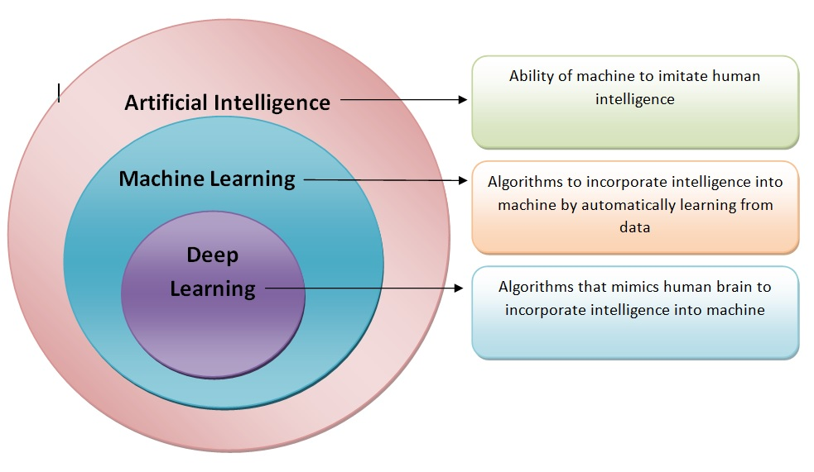
Figure 2 Model of artificial intelligence

3.2 DEEP LEARNING
Deep learning is a subset of artificial intelligence (AI) and a branch of machine learning that has come to the forefront of technological innovation in recent years. At its core, deep learning seeks to recreate the complex processes of human thinking by employing artificial neural networks – computational models inspired by the complex interconnections of neurons in the brain. These neural networks are composed of layers of interconnected nodes, or neurons, organized in a hierarchical fashion. Information flows through these layers, with each layer extracting increasingly abstract representations of the input data.
Deep learning has seen significant success in various fields, including computer vision, natural language processing, speech recognition, medical diagnosis, and more. In computer vision, deep learning models have achieved remarkable performance in tasks such as image classification, object detection, and image segmentation. In natural language processing, deep learning techniques have been applied to tasks such as language translation, sentiment analysis, and text generation.

3.2 INTRUDER DETECTION
The real-time intruder detection AI system implemented on a Raspberry Pi integrates OpenCV and a facial recognition library to fortify premises against unauthorized access. Operating with a USB camera, the system captures live feed input, continually scanning for faces within the frame. Utilizing advanced facial recognition algorithms, it compares the detected faces against a database of known individuals. This comparison process enables the system to swiftly identify any unauthorized intruders entering the monitored area.
The facial recognition component of the system employs sophisticated machine learning models trained to accurately recognize facial features and patterns. Through a combination of feature extraction and matching techniques, it identifies unique characteristics within each face and compares them against stored profiles. This process enables the system to differentiate between authorized personnel

3.3 WEBSERVER
A web server is a computer that hosts web pages, making them accessible online. When a user loads a site, the web server will retrieve the relevant files and send them to the browser so the user can interact with them.
Main component of Webserver:
3.3.1 Software: The web server software controls how users access hosted files. It comprises several components and houses at least an HTTP server to process and respond to incoming requests.
Hardware: It stores web server software and its files, such as static HTML documents, JavaScript files, and CSS style sheets. The web server hardware also connects to the internet, enabling data exchange with other physical devices.

3.3.2 HTTP: HTTP is a protocol for fetching resources such as HTML documents. It is the foundation of any data exchange on the Web and it is a client-server protocol, which means requests are initiated by the recipient, usually the Web browser. A complete document is reconstructed from the different sub-documents fetched, for instance, text, layout description, images, videos, scripts, and more.
Clients and servers communicate by exchanging individual messages (as opposed to a stream of data). The messages sent by the client, usually a Web browser, are called requests and the messages sent by the server as an answer are called response.

3.4 INTERFACES USED
In this project two interface are used UART AND I2C.
3.4.1 UART: UART stands for Universal Asynchronous Receiver/Transmitter, and it's a hardware communication protocol that defines a set of rules for exchanging serial data between two devices. UART is asynchronous, meaning it doesn't use a clock signal to synchronize the transmitter and receiver. Instead, the transmitter generates a bit stream based on its own clock signal, while the receiver uses its internal clock to sample the incoming data. The devices must have the same baud rate to manage synchronization, and a difference of up to 10% is usually acceptable.
3.4.2 I2C: I2C, or Inter-Integrated Circuit, is a serial communication protocol that uses two wires to connect devices or chips in an embedded system.I2C is a bidirectional interface that uses a controller, called the master, to communicate with slave devices. Each device on the I2C bus has a unique address to differentiate it from other devices on the bus. A slave device can't transmit data unless it's been addressed by the master.
The two wires used for communication are the serial data line (SDA) and the serial clock line (SCL):
    - SDA: Carries data.
    - SCL: Provides synchronization by pulsing at a regular interval.
I2C is commonly used to attach lower-speed peripheral ICs to processors and microcontrollers for short-distance communication within a board.

3.5 RASPBERRY PI
The first generation of computers came as massive processing systems built with vacuum tube technology. Over the years, more compact and less expensive versions of what a computer would come to look like sprung up. Today, we have minicomputer gadgets such as smartphones in our pockets. Even though computers have become so commonplace, they are still not widely accessible in developing countries. This imbalance in access to computers and programming technology led to the development and creation of the Raspberry Pi computer.
Raspberry Pi is a programmable device. It comes with all the critical features of the motherboard in an average computer but without peripherals or internal storage. To set up the Raspberry computer, you will need an SD card inserted into the provided space. The SD card should have the operating system installed and is required for the Computer to boot. Raspberry computers are compatible with Linux OS. This reduces the amount of memory needed and creates an environment for diversity.

3.6 BLOCK DIAGRAM
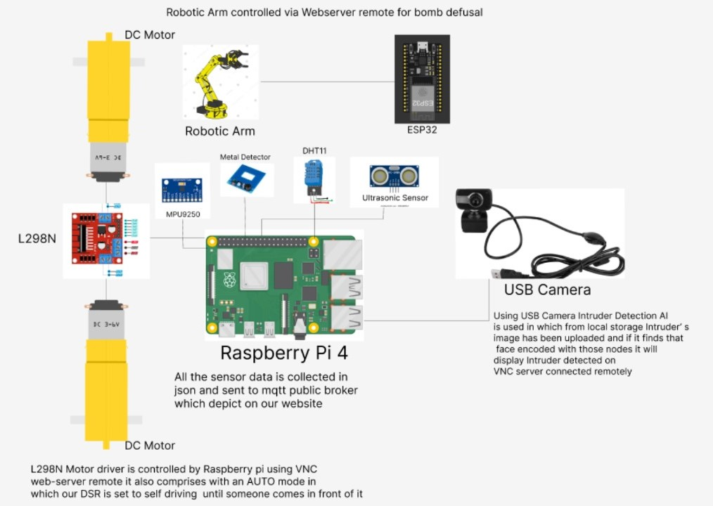

Figure 3: Block Diagram of proposed system

3.7 CIRCUIT DIAGRAM

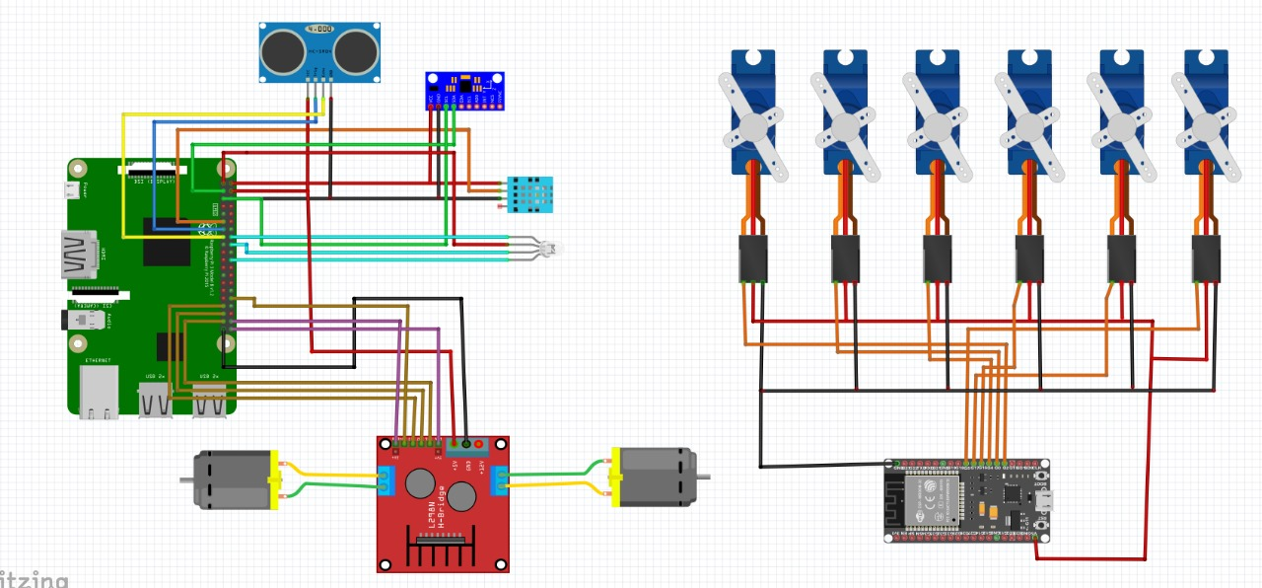

Figure 4: Circuit Diagram

CHAPTER 4

SYSTEM ARCHITECTURE

4.1 COMPONENT REQUIRED
4.1.1 MPU9250 (IMU SENSOR)
Description: It is an inertial measurement unit (IMU) that includes a 3-axis accelerometer, a 3-axis gyroscope, and a 3-axis magnetometer. This allows it to measure acceleration, angular velocity, and magnetic field strength along the three axes (X, Y, and Z), making it suitable for applications such as drones, robotics, smartphones, and other devices that need motion tracking and orientation sensing.
Functionality:
- Digital Motion Processor (DMP):The DMP is an embedded processor that performs complex calculations to offload the main processor. This includes tasks like sensor fusion algorithms, which combine data from the accelerometer, gyroscope, and magnetometer to provide more accurate orientation and motion tracking.
- Sensor Fusion: Sensor fusion algorithms combine accelerometer, gyroscope, and magnetometer data to produce more accurate orientation information. The MPU-9250's DMP can perform sensor fusion internally, or you can use external libraries to perform these calculations.
- Magnetometer Calibration: The magnetometer needs to be calibrated to correct for hard and soft iron distortions. This process involves collecting magnetometer data while rotating the sensor around all three axes and then using this data to compute correction factors.
- Using with Other Platforms: The MPU-9250 can also be used with platforms like Raspberry Pi, ESP32, or others. For these, libraries such as RTIMULib for Raspberry Pi or Adafruit Sensor combined with Adafruit_MPU6050 (with modifications for MPU-9250) can be useful.

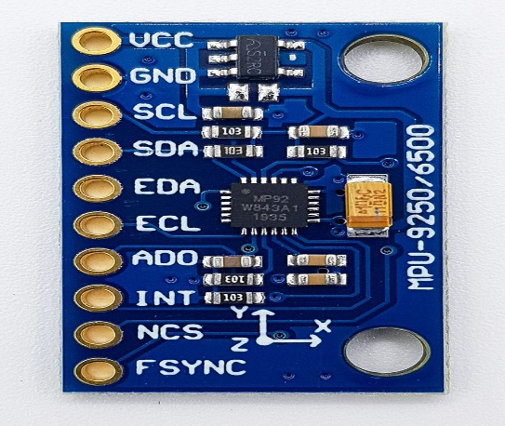
Figure 5: MPU9250 (IMU SENSOR)
4.1.2 NEO-6M GPS
Description: It's known for its high sensitivity, low power consumption, and ease of integration with microcontroller platforms such as Arduino, Raspberry Pi, and others.
Functionality:
- Geofencing: Geofencing involves creating a virtual boundary around a specific geographic area. When the GPS module detects that it has entered or exited this area, it triggers an event.
- Data Logging: Data logging involves recording GPS data over time to analyze the movement or position later. This can be done by writing the GPS data to an SD card or another storage medium.
- Integrating with Other Sensors: Integrating the NE06M GPS module with other sensors, such as accelerometers or magnetometers, enables advanced applications like dead reckoning. Dead reckoning helps maintain position tracking when GPS signals are lost or unreliable.
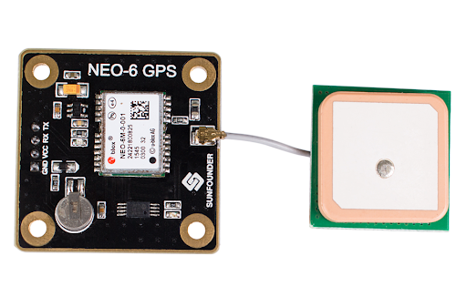
Figure 6: NEO-6M GPS

4.1.3 L298N MOTOR DRIVER
Description: The L298N is a dual H-bridge motor driver that allows you to control the speed and direction of two DC motors independently. It's commonly used in robotics and other applications where motor control is required.
Functionality:
- Speed Control with Acceleration and Deceleration: Implement smooth acceleration and deceleration to avoid sudden starts and stops, which can cause mechanical stress.
- Direction Control with PWM for Turning: Control two motors for turning a robot by varying the speed of each motor.
- PID Control for Precise Speed Regulation: Implement Proportional-Integral-Derivative (PID) control to maintain a precise motor speed.
- Current Sensing for Overcurrent Protection: Use current sensing to protect the motors from drawing too much current, which could cause damage.
- Closed-Loop Speed Control with Encoder Feedback: Use an encoder to provide feedback on the motor's speed, allowing for closed-loop control.

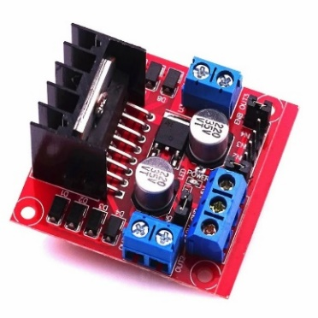
Figure 7: L298N MOTOR DRIVER

4.1.4 ULTRASONIC SENSOR (HC-SR04)
Description: Ultrasonic sensors reliably detect or measure distances within a defined measuring range without contact of the target, no matter which object properties and ambient conditions exist (e.g., presence of dust, dirt, etc.). These types of sensors emit high-frequency sound waves and measure the time elapsed from emission to hitting the object and then being reflected to the sensor, or in the case of a through-beam type, detect the blockage of the waveform between the emitter and the receiver. The measuring range of ultrasonic sensors varies depending upon the size of the sensor and ambient factors, with ranges from a few centimetres to a several meters being achievable. Key elements for this technology include transmitter performance and receiver sensitivity.
Functionality:
- Obstacle Detection and Avoidance: By using multiple ultrasonic sensors, you can detect obstacles in various directions and implement algorithms to avoid them.
- Mapping and SLAM (Simultaneous Localization and Mapping): By combining data from multiple ultrasonic sensors, you can create a map of the surroundings, useful for navigation in unknown environments.
- Multiple Sensor Integration for Better Accuracy: Using multiple sensors to cross-check measurements improves accuracy. Average readings from multiple sensors or use a voting mechanism to filter outliers.
- Object Tracking: Continuously monitor the position of moving objects using data from ultrasonic sensors. Implement algorithms to predict the object's path and update its position in real-time.
- Advanced Filtering Techniques: Apply filtering techniques such as Kalman Filter or Moving Average to reduce noise and improve measurement reliability.
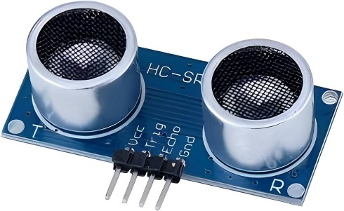

Figure 8: ULTRASONIC SENSOR (HC-SR04)

4.1.5 DHT 11
Description:
DHT11 Temperature & Humidity Sensor features a temperature & humidity sensor complex with a calibrated digital signal output. By using the exclusive digital-signal-acquisition technique and temperature & humidity sensing technology, it ensures high reliability and excellent long-term stability. This sensor includes a resistive-type humidity measurement component and an NTC temperature measurement component and connects to a high performance 8-bit microcontroller, offering excellent quality, fast response, and anti-interference ability.
Functionality:
- Data Logging and Analysis
- Purpose: Record temperature and humidity data over time for trend analysis and monitoring.
- Implementation: Use an external storage device like an SD card to store data. Periodically record the sensor readings with timestamps and later analyse the data to observe patterns, detect anomalies, or predict future environmental conditions.
- Environmental Control Systems
- Purpose: Automatically control environmental conditions such as temperature and humidity within a specified range.
- Implementation: Integrate the DHT11 with a microcontroller to control heating, ventilation, and air conditioning (HVAC) systems. For instance, if the temperature exceeds a certain threshold, the system can turn on a cooling device, or if humidity is too low, it can activate a humidifier.
- IoT Integration
    - Purpose: Monitor and control environmental conditions remotely via the Internet.
    - Implementation: Connect the DHT11 sensor to an IoT platform using Wi-Fi or other communication modules. This setup allows for real-time monitoring and control through a web interface, or a mobile app. Alerts and notifications can be set up for specific conditions (e.g., if the temperature exceeds a certain level).
- Greenhouse Monitoring and Control
- Purpose: Maintain optimal growing conditions in a greenhouse.
- Implementation: Use the DHT11 to continuously monitor the temperature and humidity levels inside the greenhouse. Based on the sensor readings, automatically control fans, heaters, and irrigation systems to ensure plants are in an ideal environment for growth.
- Smart Home Automation
- Purpose: Enhance comfort and energy efficiency in smart homes.
- Implementation: Integrate the DHT11 with a home automation system to control smart thermostats, humidifiers, and dehumidifiers. Use the sensor data to create custom automation rules, such as turning on the air conditioner when the temperature rises above a set point or adjusting the humidity based on personal preferences.

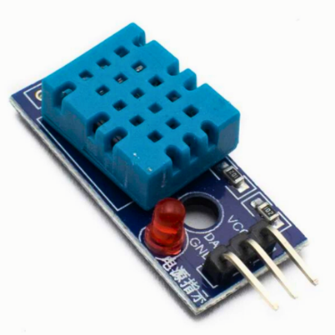

Figure 9: DHT 11 TEMPERATURE AND HUMIDITY SENSOR

4.1.6 ROBOTIC ARM
Description: Robotic arms, also known as articulated robotic arms, are fast, reliable, and accurate and can be programmed to do an infinite number of tasks in a variety of environments. In the past, a robotic arm required teaching to perform narrowly defined tasks, such as picking a single type of object from a precise location with a specific orientation.
Functionality:
- Precision and Accuracy:
- Purpose: Achieve high precision and accuracy in tasks such as assembly, painting, welding, and surgery.
- Implementation: Use advanced control algorithms, high-resolution encoders, and feedback systems to ensure precise movements and positioning.
- Inverse Kinematics:
- Purpose: Calculate the required joint angles to position the end effector (tool or gripper) at a desired location in space.
- Implementation: Use inverse kinematics algorithms to determine the joint configurations based on the desired position and orientation of the end effector.
- Path Planning:
- Purpose: Plan and execute optimal paths for the robotic arm to move from one point to another, avoiding obstacles.
- Implementation: Use path planning algorithms such as A, rapidly exploring Random Trees (RRT), or Probabilistic Roadmaps (PRM) to find collision-free paths.
- Force Sensing and Feedback:
- Purpose: Measure and respond to forces exerted on the arm to perform tasks requiring delicate touch or precise force application.
- Implementation: Integrate force/torque sensors at the joints or end effector, and use feedback control to adjust movements based on real-time force data.
- Machine Learning and AI:
- Purpose: Enhance the arm's capabilities through learning from data and adapting to new tasks or environments.
- Implementation: Use machine learning algorithms to recognize patterns, optimize movements, and improve task execution through reinforcement learning, supervised learning, or unsupervised learning.

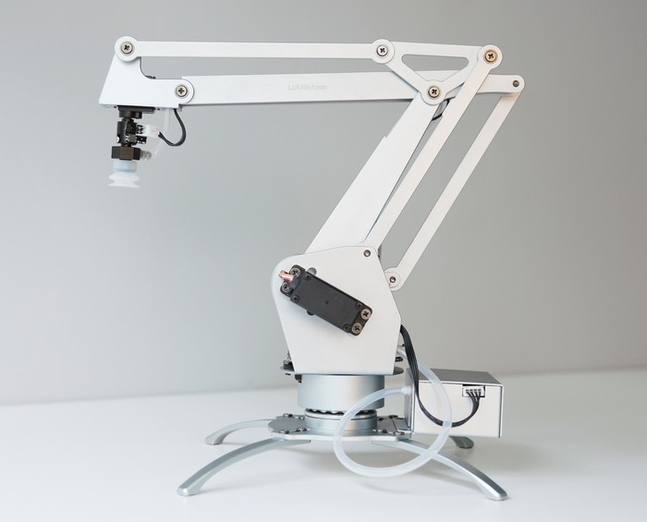

Figure 10: ROBOTIC ARM

4.1.7 WEB SERVER CONTROLLED REMOTE
Description: Controlling a robotic arm remotely through a web server allows for flexible and convenient operation from anywhere with internet access.
Functionality:
- Advanced Path Planning and Obstacle Avoidance:
- Purpose: Ensure the robotic arm can navigate complex environments and avoid obstacles efficiently.
- Implementation:
- Path Planning Algorithms: Utilize algorithms like Rapidly exploring Random Trees (RRT) or A* to plan collision-free paths.
- Real-time Obstacle Detection: Integrate sensors such as LIDAR, ultrasonic sensors, or cameras to detect obstacles and dynamically adjust paths.
- Machine Learning and AI Integration:
- Purpose: Enhance the robotic arm’s adaptability and learning capabilities for complex tasks.
- Implementation: Reinforcement Learning: Implement reinforcement learning algorithms to allow the arm to improve its performance through trial and error.
- Computer Vision: Use AI-powered computer vision to recognize objects, track movements, and adapt to new tasks.
- Force Sensing and Adaptive Control:
- Purpose: Enable the robotic arm to handle delicate objects and apply precise amounts of force.
- Implementation:
- Force/Torque Sensors: Integrate force/torque sensors at the end effector to measure applied forces.
- Adaptive Control Algorithms: Implement control algorithms that adjust the arm’s movements based on real-time force feedback, ensuring safe and precise interactions with objects.
- Collaborative Robotics (Cobots):
- Purpose: Allow the robotic arm to work safely alongside human operators.
- Implementation:
- Safety Features: Include features like force limiting, collision detection, and compliant control to ensure safe interaction with humans.
- Human-Machine Interface: Develop intuitive interfaces and control schemes to facilitate human-robot collaboration.
- Teleportation with Haptic Feedback:
- Purpose: Provide operators with tactile feedback for more intuitive remote control.
- Implementation:
- Haptic Devices: Use haptic devices to give operators tactile feedback corresponding to the arm’s interactions.
- Teleportation Interface: Develop a teleportation system that allows operators to control the arm remotely while feeling the forces exerted by the arm.
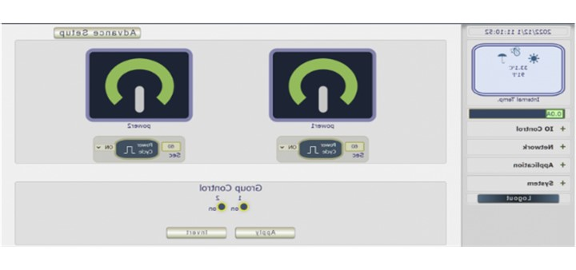
Figure 11: WEB SERVER CONTROLLED REMOTE

4.1.8 RASBERRY PI 4
Description: The Raspberry Pi is a very cheap computer that runs Linux, but it also provides a set of GPIO (general purpose input/output) pins, allowing you to control electronic components for physical computing and explore the Internet of Things (IoT). The Raspberry Pi Foundation works to put the power of computing and digital making into the hands of people all over the world. It does this by providing low-cost, high-performance computers that people use to learn, solve problems, and have fun.
Functionality:
- Teaching basic computer science: The Raspberry Pi is often used in schools and educational settings to introduce students to the basics of computer science and programming. It is a versatile platform that can be used to build and run a wide range of software, from simple games and simulations to more advanced applications and tools.
- Building home automation and Internet of Things (IoT) projects: The Raspberry Pi can be used as the brains of a home automation or IoT system, allowing users to control and monitor devices in their home over the internet. This can include things like turning lights on and off, controlling the thermostat, and monitoring security cameras.
- Developing and testing software: The Raspberry Pi can be used as a platform for developing and testing new software and applications. It has a large and active community of users and developers who contribute to the platform, which makes it a great place to learn, experiment, and collaborate.
- Playing games and running media applications: The Raspberry Pi can run a wide range of games and media applications, including retro games, streaming services, and more. This makes it a great platform for home entertainment and gaming.
- Building custom projects: Because of its small size and low power consumption, the Raspberry Pi is often used as the building block for custom projects and prototypes. It can be used to create everything from weather stations and radios to robots and drones.
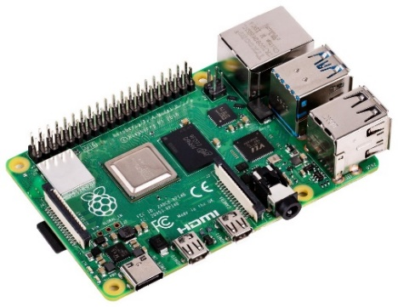
Figure 12: RASBERRY PI 4

4.2 COMPONENT TABLE

S NO. | COMPONENTS | QUANTITY
1 | RASBERRY PI 4 (MODEL B) | 1
2 | MPU9250 (IMU SENSOR) | 1
3 | L298N MOTOR DRIVER | 1
4 | NEO-6M GPS | 1
5 | DHT 11 | 1
6 | ULTRASONIC SENSOR (HC-SR04) | 1
7 | ROBOTIC ARM | 1
8 | ESP 32 | 1
9 | SERVO | 6
10 | DIY METAL DETECTOR | 1
11 | DC MOTOR | 2
12 | WEB CAM | 1

Table 1: Component Required Table

4.3 HARDWARE IMPLEMENTATION
The hardware implementation of our surveillance project involves integrating advanced robotics, artificial intelligence, and remote-control capabilities into a compact yet powerful system. Equipped with sensors including cameras, infrared detectors, and environmental sensors for temperature and humidity monitoring, along with specialized modules for license plate and metal detection, our hardware platform enables real-time data collection and analysis. Additionally, GPS functionality ensures accurate tracking and navigation. With the inclusion of a robotic arm for remote manipulation and interaction, our system represents a sophisticated solution for comprehensive surveillance and response.
Through the hardware implementation of our project, we have arranged an array of components to build a complex and responsive system suitable for a wide range of uses, we've integrated various components to enhance the functionality of our system. These are-

4.3.1 Raspberry Pi
Our hardware structure is built around the Raspberry Pi, an amazing example of modern computing that offers the flexibility and computational power required to control a wide range of sensors, actuators, and peripherals. This credit-card-sized computer, created by the Raspberry Pi Foundation, has completely changed the field of embedded computing by allowing professionals, educators, and hobbyists to investigate the domains of robotics, electronics, and programming. The Raspberry Pi is fundamentally equipped with a potent ARM-based processor that can handle complicated instructions with amazing speed. Real-time responsiveness and smooth multitasking are made possible by the Raspberry Pi's multicore CPU, which guarantees quick task execution when parsing GPS data, processing sensor readings, or streaming live video. By taking advantage of the Raspberry Pi's capabilities as a central processing unit, we have coordinated a group of sensors, actuators, and controllers to add intelligence and functionality to our system.
By utilising its strong processing powers, the Raspberry Pi coordinates the application of deep learning models and artificial intelligence algorithms, allowing for the intelligent real-time analysis of surveillance data. The Raspberry Pi enables complete situational awareness through its interface with a wide range of sensors, such as cameras for visual monitoring, infrared detectors for intrusion detection, and special modules for metal detection and licence plate identification. In addition, environmental sensors that measure temperature and humidity offer useful background, and GPS technology guarantees accurate geolocation tracking. By allowing for remote manipulation and interaction with the surroundings, the addition of a robotic arm gives our surveillance capabilities a dynamic new dimension. The Raspberry Pi changes the environment by enabling our surveillance system with unmatched flexibility, adaptability, and reactivity through the skilful integration of these components.

4.3.2 Ultrasonic Sensor (HC-SR04)
In the field of distance measurement, the HC-SR04 ultrasonic sensor is a pillar that supports the obstacle recognition and proximity sensing features of our system. Its operation relies on the principles of ultrasonic waves, ultrasonic vibrations travel through the atmosphere and reflect through nearby objects. The transmitter and the receiver are the two primary parts of this sensor. Through its transmitter, the sensor sends out a burst of ultrasonic waves to begin measuring distance. When they come across an obstruction, these pulses travel through the air at the speed of sound and reflect back towards the sensor. Following the detection of the reflected pulses by the receiver, the sensor determines the distance to the obstacle using the measurement of the round-trip time, the sensor calculates the distance to the obstacle with remarkable accuracy.
Applications ranging from basic obstacle avoidance in robotics to precise object tracking in industrial automation depend on the accuracy of the distance measurement. The HC-SR04 sensor has a several-meter range and provides reliable performance in a variety of situations. Carefully configuring the GPIO (General Purpose Input/Output) pins makes it easier to integrate the HC-SR04 sensor with the Raspberry Pi. By providing signals to start the ultrasonic pulses and then timing the return of the reflected signals, the Raspberry Pi controls the sensor's functions. The HC-SR04 sensor operates smoothly and dependably because to the Raspberry Pi's accurate timing management and effective signal processing, which gives our system the confidence and accuracy to confidently negotiate obstacles and maintain situational awareness.
Connections:
- VCC to 5V.
- GND to GND.
- TRIG to GPIO23.
- ECHO to GPIO24.

4.3.3 NEO-6M GPS Module
As a dependable source for accurate location information required for a variety of applications, the Neo 6M GPS module plays a critical role in our project's navigation and positioning capabilities. Basically, the Neo 6M module uses an array of satellites in Earth's orbit to precisely determine its location through geolocation. The Neo 6M module gets signals from several satellites in its line of sight to start the procedure. Through a process known as trilateration, the module is able to determine its position thanks to the precise timing information and satellite coordinates contained in these messages. The module calculates its precise latitude, longitude, altitude and satellite positions by timing the signals' arrival at each satellite and taking into account the speed of light.
The Neo 6M GPS module's UART (Universal Asynchronous Receiver-Transmitter) interface makes it easier to integrate with the Raspberry Pi. The module and the Raspberry Pi can communicate serially with ease thanks to this interface, exchanging data packets with location data and status updates. The Raspberry Pi interprets the data it receives from the GPS module to extract important position characteristics, such latitude and longitude. After that, this data can be used for a number of purposes, such as real-time tracking for asset management and logistics, geotagging for photography and mapping, and autonomous navigation for unmanned vehicles.
Our project gains unmatched awareness of space thanks to the Neo 6M GPS module's real-time positioning data, which facilitates accurate navigation and location-based decision-making. With the Neo 6M GPS module integrated with the Raspberry Pi, our system can do tasks like routing emergency responders across complex environments or directing autonomous drones to new heights of accuracy and dependability.
Connections:
- VCC to 3.3V or 5V (depending on the module's specifications).
- GND to GND.
- TX to GPIO15 (UART RX).
- RX to GPIO14 (UART TX).

4.3.4 MPU9250 (IMU Sensor)
Our project has been enhanced significantly by the MPU-9250 9-axis accelerometer, which offers unmatched spatial awareness and orientation detection capabilities. Its gyroscope, magnetometer, and tri-axis accelerometer combine to record a wide variety of motion-related data. The MPU-9250 provides vital information on the dynamics and orientation of the system's movement, from detecting changes in magnetic fields to measuring angular velocity and detecting acceleration. The I2C (Inter-Integrated Circuit) protocol makes integration with the Raspberry Pi easy and facilitates simple communication between the sensor and the Pi. This enables the real-time collection and processing of motion data, giving our system the capacity to decide intelligently and adapt quickly to changes in its surroundings.
Our project performs better in a variety of scenarios thanks to the MPU-9250's accurate motion detection capabilities. The MPU-9250 is a crucial component that ensures precision, dependability, and effectiveness in a variety of applications, including autonomous vehicle navigation, tracking motion in virtual reality environments, and motion-controlled device orientation stability.
All things considered, the addition of the MPU-9250 9-axis accelerometer to our hardware ecosystem improves our project significantly and opens the way for our project's sophisticated motion sensing and spatial awareness. Its accuracy, adaptability, and smooth interaction with the Raspberry Pi make it an essential part of our pursuit of excellence and innovation.
Connections:
- VCC to 3.3V.
- GND to GND.
- SDA to GPIO2 (SDA).
- SCL to GPIO3 (SCL).

4.3.5 L298N Motor Driver
A key component of our project activation capabilities is the L298N motor driver, which offers accurate and dependable control over the movement of motors with grace and precision. The L298N motor driver is a powerful motor driver that can handle the demands of robotic platforms, mechanical arms, and other mechanical devices. The four input pins—two for each motor—dedicated to motor control are essential to its operation. The Raspberry Pi can send signals using these input ports to determine the speed and direction of rotation for each motor. Our project exhibits amazing accuracy and responsiveness in executing a wide range of motor movements, such as forward and reverse rotations and variable speed adjustments, by simply flipping the necessary input pins.
The L298N motor driver has two enable pins, one for each motor, in addition to motor control. The Raspberry Pi can activate or deactivate each motor as needed by using these enabling pins as activation switches. With this capability, you can precisely regulate when motors are engaged or disengaged, which is especially helpful for power management and safety concerns. Because the L298N motor driver is compatible with GPIO (General Purpose Input/Output) pins, integration with the Raspberry Pi is smooth. Via these GPIO pins, the Raspberry Pi interfaces with the motor driver, controlling the motor's direction and speed by providing signals to the input pins. Dynamic motor control, made possible by this bidirectional communication, permits fluid and effective movement in response to shifting external circumstances or user inputs.
Connections:
- IN1 to GPIO5.
- IN2 to GPIO6.
- IN3 to GPIO13.
- IN4 to GPIO19.
- ENA to GPIO12 (or directly to 5V for constant on).
- ENB to GPIO18 (or directly to 5V for constant on).
- Motor Power Supply to 12V and GND.
- Motors to the output terminals of the L298N.

4.3.6 DHT11
Our project's ability to precisely and responsively monitor environmental conditions has been improved with the addition of the DHT11 sensor. The DHT11 is tasked with detecting temperature and humidity levels. It uses an integrated thermistor and humidity sensor to collect data with exceptional accuracy, which is essential for applications ranging from agriculture to climate management. The sensor easily interacts with the Raspberry Pi due to its direct digital communication protocol, providing real-time environmental data for pre-emptive decision-making.
When the Raspberry Pi receives data from the DHT11 sensor, it quickly processes it to extract the necessary temperature and humidity values. This data is the foundation for performance optimisation in a variety of applications, allowing our system to adapt dynamically to changing environmental conditions. Whether controlling temperature in controlled settings or keeping an eye on humidity levels in agricultural settings, our system is able to effectively maintain ideal conditions thanks to the real-time information that the DHT11 offers.
Moreover, the early detection of abnormalities capabilities of the DHT11 sensor allow our project to proactively address possible problems, enhancing operational reliability and reducing risks related to environmental variations. Through utilisation of this sophisticated monitoring feature, our system improves its responsiveness and flexibility, guaranteeing reliable operation and ideal environmental circumstances.
Connections:
- VCC to 3.3V.
- GND to GND.
- Data to GPIO17 (use a 10k pull-up resistor between VCC and Data if needed).

4.3.7 Metal Detector Module
The metal detector sensor serves as a careful protector in our sensor suite, acting as a reliable defence against metallic intrusions. Its main job is to find variations in electromagnetic fields caused by metallic objects in nearby areas so that our system can quickly recognise any hazards. Since metallic objects frequently present safety issues or signal unauthorised entry, this capacity is essential to improving security procedures. The sensor notifies operators to a possible hazard by triggering a sequence of alarms when it detects a metallic object. These warnings usually consist of visual indications and auditory sounds that give clear, instantaneous signals of the discovered hazard. By rapidly alerting operators to the presence of metallic objects, this rapid response mechanism makes sure that any possible dangers or security breaches are avoided.
Furthermore, our system now has an extra layer of protection and danger detection capabilities thanks to the inclusion of the metal detector sensor. The metal detector sensor improves our system's overall surveillance and monitoring capabilities by completing the suite of sensors that includes cameras and motion detectors. This allows for full coverage and the detection of potential threats from a variety of sources. Essentially, the metal detector sensor is a vital component that supports the security posture of our system by offering a reliable way to identify metallic attacks and instantly notify operators of any potential dangers. It is an essential part of our search for improved security and threat detection capabilities because of its dependable performance and quick reaction times.
Connections:
- VCC to 5V.
- GND to GND.
- Signal Output to GPIO25.

4.3.8 Servos (6 for Robotic Arm)
The integration of a web server interface into our project represents a significant leap forward in embracing remote control and automation capabilities. This interface serves as a gateway for operators to remotely control our system's robotic arm from any location with internet access. The six servos dedicated to our robotic arm. These servos serve as the mechanical muscle of our system, allowing precise control over the arm's movements. Each servo is responsible for actuating a specific joint or segment of the robotic arm, enabling it to perform a wide range of tasks with dexterity and accuracy. From picking up objects to manipulating controls, the versatility of the robotic arm empowers our system with the capability to interact with its environment in a dynamic and responsive manner.
By accessing a web page hosted by the system, operators gain intuitive and user-friendly control over the robotic arm's movements, unlocking a wealth of applications across various industries and scenarios. Central to the functionality of the web server interface is its ability to provide seamless servo motor control. Through the web interface, operators can send commands to the servo motors responsible for controlling the robotic arm's joints and movements. By adjusting the position and speed of each servo motor, operators can manipulate the robotic arm with precision and dexterity, performing intricate tasks with ease and accuracy.

Connections:
- VCC to an external 5V power supply.
- GND to the ground of the power supply and the Raspberry Pi.
- Control wires to GPIO pins (e.g., GPIO4, GPIO27, GPIO22, GPIO10, GPIO9, GPIO11).

4.3.9 USB Camera Module
The USB Camera Module is a crucial component in our advanced surveillance system, providing real-time visual monitoring and analysis capabilities essential for threat detection and situational awareness. Positioned strategically within the system, this module captures high-resolution video footage of the surrounding environment, enabling detailed observation of events and activities. Integrated with artificial intelligence algorithms, the camera module facilitates advanced video analytics such as facial recognition and object detection, enhancing the system's ability to detect and respond to security threats with precision.
The integration of the USB camera module into our system involves careful consideration of hardware interfacing and mounting. Compatible with the Raspberry Pi or similar microcontroller platforms, the USB camera module connects directly to the system's USB port. Additionally, mounting the camera module in a strategic location ensures optimal coverage of the surveillance area, maximizing the effectiveness of visual monitoring and analysis.
In conclusion with other hardware components such as intruder detection sensors, robotic arms, license plate detection systems, metal detectors, temperature sensors, humidity sensors, and GPS modules, the USB camera module forms an integral part of our comprehensive surveillance system. By harnessing the power of visual data and artificial intelligence, our system is equipped to detect, analyse, and respond to security threats with precision and efficiency, making it a formidable asset in various surveillance and security applications.

4.3.10 Chassis Frame and PVC
Our hardware platform is fortified with a robust chassis frame and a PVC body, meticulously designed to ensure structural integrity and durability in demanding environments. The chassis frame, crafted from high-quality materials such as aluminium or steel, provides a stable and secure foundation for mounting our system's components. Engineered to withstand mechanical stresses and vibrations, the frame offers reliability even in dynamic operational conditions.
Complementing the chassis frame is the PVC body, chosen for its exceptional resilience to environmental factors such as high temperatures, moisture, and physical impact. PVC's inherent properties make it an ideal choice for protecting sensitive electronics from harsh conditions. Reinforced with additional structural elements, such as reinforcement ribs or panels, the PVC body further enhances durability and strength, ensuring our system's longevity in challenging settings.
Through meticulous design, construction, and testing, our hardware platform meets stringent standards for reliability and durability. From industrial settings to outdoor deployments, the combination of a sturdy chassis frame and a resilient PVC body ensures that our system remains steadfast and dependable, providing peace of mind in the face of adversity.

4.4 SOFTWARE IMPLEMENTATION
This chapter provides a comprehensive guide to setting up a Raspberry Pi for software development, installing necessary libraries and tools, and integrating software using Python, Node.js, and React.js. The development environment will utilize Visual Studio Code (VS Code) and Thonny IDE.

4.4.1 Installing Raspberry Pi OS using Raspberry Pi Imager
4.4.1.1 Download Raspberry Pi Imager:
- Visit the Raspberry Pi Imager download page.
- Download and install the Imager for your operating system.
4.4.1.2 Prepare the MicroSD Card:
- Insert the MicroSD card into the card reader connected to your computer.
4.4.1.3 Flash Raspberry Pi OS:
- Open Raspberry Pi Imager.
- Click on "Choose OS" and select "Raspberry Pi OS (32-bit)".
- Click on "Choose SD Card" and select your MicroSD card.
- Click "Write" to start the installation process.
- Once complete, insert the MicroSD card into the Raspberry Pi.
4.4.1.4 Initial Setup:
- Connect the Raspberry Pi to the monitor using the HDMI cable.
- Connect the keyboard and mouse.
- Power up the Raspberry Pi.
- Follow the on-screen instructions to set up the operating system (language, time zone, Wi-Fi, etc.).

4.4.2 Installing Necessary Libraries and Tools
4.4.2.1 System Update: Open a terminal and update your system:
      - sudo apt update
      - sudo apt upgrade -y
4.4.2.2 Installing Python and Necessary Libraries
Python is pre-installed on Raspberry Pi OS. To ensure you have the latest version and necessary libraries:
      - sudo apt install python3-pip -y
      - pip3 install --upgrade pip
      - pip3 install numpy pandas flask requests
4.4.2.3 Installing Node.js and npm
      - Install Node.js and npm (Node Package Manager):
      - curl -sL https://deb.nodesource.com/setup_14.x | sudo -E bash -
      - sudo apt install nodejs -y
4.4.2.4 Installing Visual Studio Code
      - Update and Install VS Code:
      - sudo apt update
      - sudo apt install code -y
4.4.2.5 Installing Thonny IDE
Thonny is an integrated development environment (IDE) for Python that is designed to be simple and beginner friendly. It provides a clean and intuitive interface, making it particularly suitable for teaching programming to beginners. Thonny comes with features like code completion, syntax highlighting, and a debugger, all aimed at aiding users in writing and debugging Python code effectively. Thonny comes pre-installed with the Raspberry Pi OS. If not, install it using:
      - sudo apt install thonny -y

4.4.3 Development Using VS Code and Thonny
4.4.3.1 Setting Up VS Code
4.4.3.1.1 Open VS Code:
- Launch VS Code from the applications menu
4.4.3.1.2 Install Python Extension:
- Go to the Extensions view by clicking the Extensions icon or pressing Ctrl+Shift+X.
- Search for "Python" and install the extension by Microsoft.
4.4.3.1.3 Configure Python Interpreter:
- Open a Python file or create a new one.
- Click on the Python version in the bottom-left corner of the window and select the appropriate interpreter.
4.4.3.2 Using Thonny IDE
4.4.3.2.1 Open Thonny:
- Launch Thonny from the applications menu.
4.4.3.2.2 Simple Python Development:
- Thonny is user-friendly and excellent for beginners.
- Create a new file, write your Python code, and run it directly within the IDE.
Certainly! Let's delve into more detailed aspects of each software component in the surveillance project:

4.4.4 Sensor Interface:
4.4.4.1Temperature and Humidity Sensor (DHT11):
- Implement a module to read data from the DHT11 sensor using libraries such as Adafruit_DHT.
- Periodically poll the sensor to retrieve temperature and humidity readings.
- Implement error handling for sensor failures or communication errors.
4.4.4.2 Ultrasonic Distance Sensor:
- Develop a module to interface with the ultrasonic sensor (HC-SR04).
- Use GPIO pins to trigger and capture echo signals to measure distances.
- Implement a function to calculate distance based on the time difference between sending and receiving ultrasonic pulses.
- Apply filtering techniques to remove noise and improve distance measurement accuracy.
4.4.4.3 GPS Module:
  - Create a module to communicate with the GPS module via serial communication (using PySerial).
  - Parse NMEA sentences received from the GPS module to extract latitude and longitude coordinates.
  - Implement error handling for cases where GPS data is unavailable or inaccurate.
4.4.4.4 Metal Detector:
  - Interface with the metal detector sensor to detect the presence of metal objects.
  - Read analog or digital signals from the sensor to determine metal detection.
  - Apply thresholding or signal processing techniques to distinguish between metal and non-metal objects.

4.4.5 AI Algorithms:
4.4.5.1 Face Recognition:
  - Utilize pre-trained deep learning models (e.g., OpenCV's DNN module or TensorFlow) for face detection and recognition.
  - Train custom models or use existing datasets for face recognition tasks.
  - Implement real-time face detection and recognition algorithms using techniques like Haar cascades or deep learning-based approaches (e.g., CNNs).
4.4.5.2 License Plate Detection:
  - Employ deep learning models (e.g., YOLO, SSD) trained on license plate datasets for detection.
  - Integrate algorithms to extract and recognize license plate characters.
  - Implement image processing techniques (e.g., edge detection, morphological operations) to enhance license plate detection accuracy.
4.4.6 Control Logic:
4.4.6.1Autonomous Navigation:
  - Develop algorithms for obstacle avoidance and path planning using sensor data (e.g., ultrasonic distance sensor).
  - Implement PID controllers or other control strategies for motor control to achieve desired movement trajectories.
4.4.6.2Object Manipulation (Robotic Arm):
  - Design control algorithms to operate the robotic arm based on detected objects (e.g., intruders).
  - Implement inverse kinematics or motion planning algorithms to position the robotic arm accurately.

4.4.7 Communication Module:
4.4.7.1 MQTT for IoT Communication:
  - Use the MQTT protocol for lightweight, efficient communication between the surveillance system components.
  - Implement MQTT client libraries (e.g., paho-mqtt) to publish sensor data and subscribe to control commands.
4.4.7.2 WebSocket for Real-Time Remote Control:
- Develop a WebSocket server to enable real-time bidirectional communication between the surveillance system and remote clients (e.g., web browsers, mobile apps).
- Implement event-driven programming to handle WebSocket connections and message exchange.

4.5 KEY LIBRARIES

Library | Installation Command
RPi.GPIO | sudo apt-get install python3-rpi.gpio
Adafruit_DHT | pip3 install Adafruit_DHT
smbus | sudo apt-get install python3-smbus
serial (pyserial) | pip3 install pyserial
opencv-python-headless | pip3 install opencv-python-headless
face recognition | pip3 install face recognition
Flask | pip3 install Flask
Flask-Socket IO | pip3 install Flask-Socket IO
paho-mqtt | pip3 install paho-mqtt

Table 2: Key Libraries

CHAPTER 5

WORKING AND OPEARATION

  - WORKING
5.1.1 Functionalities:
5.1.1.1 Remote Control: The robot can be manually controlled through a web interface. Users can adjust the speed and direction of the robot using buttons and sliders.
5.1.1.2 Autonomous Driving: The robot can navigate autonomously using ultrasonic sensors to avoid obstacles. When in self-driving mode, the robot moves forward and changes direction upon detecting an obstacle within 10 cm.
5.1.1.3 Face Recognition: The robot uses a camera and face recognition software to identify faces in real-time. If an intruder is detected, an alert is displayed on the video feed.
5.1.1.4 Environmental Monitoring: The robot periodically measures and publishes environmental data such as temperature, humidity, distance to obstacles, and orientation (pitch, roll, and yaw) via MQTT.
5.1.1.5 GPS Tracking: The robot captures GPS data to provide its current location.
5.1.1.6 Visual Indicators: The robot has a police light feature that flashes LEDs to signal its activity.

5.1.2 Detailed Working:
5.1.2.1 Initialization and Setup
- GPIO Setup: Initializes GPIO pins for motor control, sensors, and LEDs.
- PWM Configuration: Configures PWM for motor speed control.
- MQTT Connection: Establishes a connection to the MQTT broker for data publishing.
5.1.2.2 Motor Control
- Move Forward/Backward: Activates the appropriate GPIO pins and sets PWM signals to move the motors.
- Turn Left/Right: Activates the GPIO pins in a specific pattern to turn the robot.
- Stop: Deactivates all motor related
- GPIO pins to stop the robot.
5.1.2.3 Sensor Data Acquisition
- Temperature and Humidity: Reads data from the DHT11 sensor.
- Distance Measurement: Uses the ultrasonic sensor to measure the distance to obstacles.
- Orientation: Reads acceleration, gyroscope, and magnetometer data from the MPU9250. Uses a complementary filter to calculate pitch, roll, and yaw.
- GPS Data: Parses NMEA sentences from the GPS module to obtain latitude and longitude.
5.1.2.4 Intruder Detection
- Image Capture: Continuously captures frames from the camera.
- Face Detection: Uses face recognition libraries to detect and compare faces in the captured frames.
- Intruder Alert: Displays an alert on the web interface if a recognized face is detected.
5.1.2.5 Data Communication
- MQTT Publishing: Publishes sensor data in JSON format to a predefined topic.
- Web Interface: Provides real-time control and monitoring through Flask and Flask-Socket IO. Users can send commands to control the robot and receive feedback.
5.1.2.6 Autonomous Driving
- Self-Driving Logic: Continuously checks distance to obstacles and adjusts the robot's movement accordingly.
- Obstacle Avoidance: Moves backward and changes direction if an obstacle is detected within a predefined distance.
5.1.2.7 Police Light
- LED Blinking: Blinks LEDs in a specific pattern to simulate police lights.
5.1.2.8 Running the System
- Setup: Initialize sensors, motors, and communication modules.
- Start Flask Server: Run the Flask application to provide the web interface.
- Start Face Recognition: Begin the face recognition thread to monitor the video feed.
- Periodic Data Publishing: Continuously read sensor data and publish it via MQTT at regular intervals.
- Autonomous and Manual Control: Switch between manual control via the web interface and autonomous driving as needed.

5.1.3 Key Features
5.1.3.1 Intruder Detection AI using USB Camera:
- Functionality: The system uses a USB camera to capture live video feeds for intruder detection.
- Process: Pre-encoded images of authorized individuals are stored locally. During operation, the robot scans face in the live video feed and compares them to the stored images.
- Alert Mechanism: If an unrecognized face (intruder) is detected, the system displays an "Intruder Detected" message on a VNC server connected remotely.
- Application: This feature ensures continuous monitoring and alerts security personnel about unauthorized entries in real-time.
5.1.3.2 Sensor Data Collection and MQTT Communication:
- Data Collection: The robot is equipped with various sensors (temperature, humidity, distance, acceleration, gyroscope, GPS) to monitor environmental and positional parameters.
- Data Format: Sensor data is formatted into JSON objects.
- Communication: The JSON-formatted sensor data is sent to a public MQTT broker.
- Node.js Script: A Node.js script subscribes to the MQTT topic and processes the incoming data.
- Frontend Integration: The processed data is then forwarded to a frontend application built with React.js.
- Application: This provides a centralized platform for monitoring the robot’s status and environmental conditions remotely via a web interface.
5.1.3.3 L298N Motor Driver Control via Raspberry Pi:
- Manual Control: The robot can be controlled manually using a web-server remote interface accessible via VNC.
- Auto Mode: In auto mode, the robot operates autonomously. It moves forward until an obstacle (e.g., a person) is detected in front of it, at which point it stops or changes direction.
- Motor Control: The L298N motor driver is used to control the movement of the robot, enabling forward, backward, left, and right movements.
- Application: This feature allows both manual and autonomous operation, making the robot versatile for different scenarios.
5.1.3.4 Robotic Arm Control for Bomb Defusal using ESP32:
- Functionality: The robotic arm is controlled via a web-server interface hosted on an ESP32 microcontroller.
- Control Interface: Users can access the web server to manipulate the robotic arm remotely.
- Application: The robotic arm can be used for delicate tasks such as bomb defusal, enhancing the robot’s utility in hazardous situations.

5.1.4 System Workflow
5.1.4.1 Setup and Initialization:
  - Initialize the sensors, motor drivers, and camera.
  - Load reference images for intruder detection and encode facial features.
  - Set up the ESP32 web server for robotic arm control.
5.1.4.2 Intruder Detection Operation:
- Start capturing video from the USB camera.
- Continuously process video frames to detect and encode faces.
- Compare detected face encodings with pre-stored reference encodings.
- If an intruder is detected, send an alert to the remote VNC server.
5.1.4.3 Sensor Data Monitoring and Communication:
- Collect sensor data at regular intervals.
- Format the data into JSON and publish it to the MQTT broker.
- A Node.js script subscribes to the MQTT topic to receive the data.
- The Node.js script processes the data and sends it to the frontend application built with React.js.
- The React.js frontend displays the data for real-time monitoring on a web interface.
5.1.4.4 Manual and Autonomous Movement:
  - Manual control via VNC: Users can send commands to move the robot in different directions.
  - Autonomous mode: The robot moves forward until an obstacle is detected, then stops or navigates around it.
5.1.4.5 Robotic Arm Operation:
  - Access the ESP32 web server interface to control the robotic arm.
  - Perform tasks such as bomb defusal using the robotic arm.

  - CODE

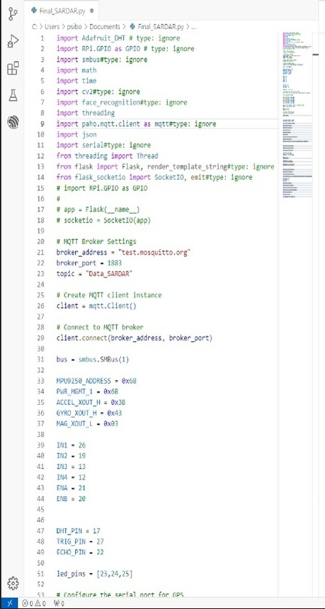

Figure 13: Code

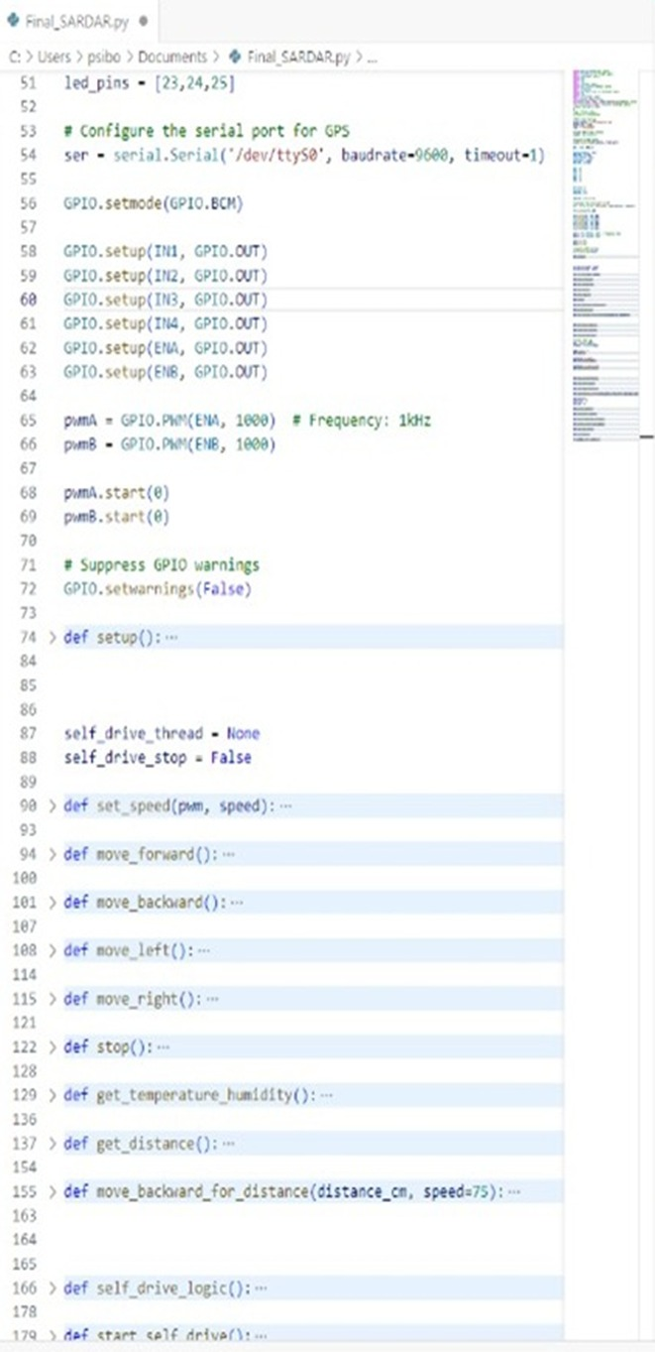

Figure 14: Code

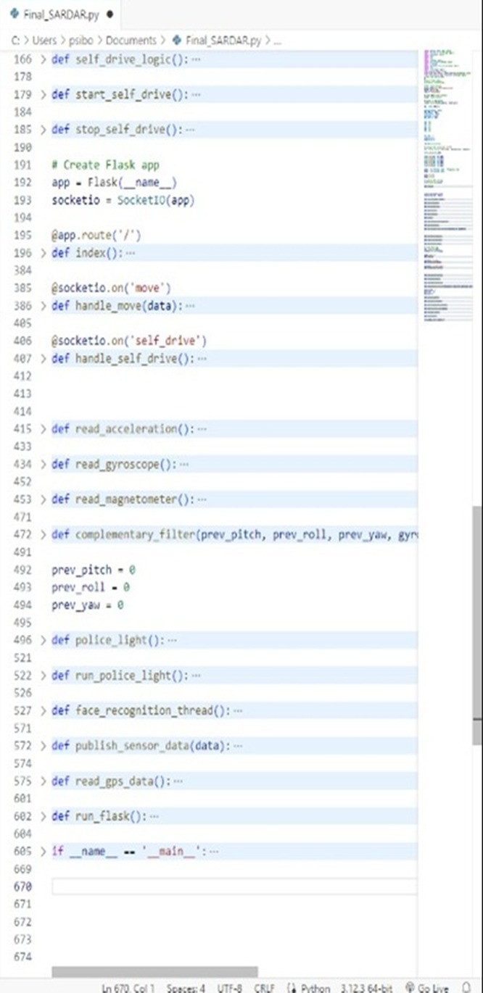

Figure 15: Code
  - FLOW DIAGRAM

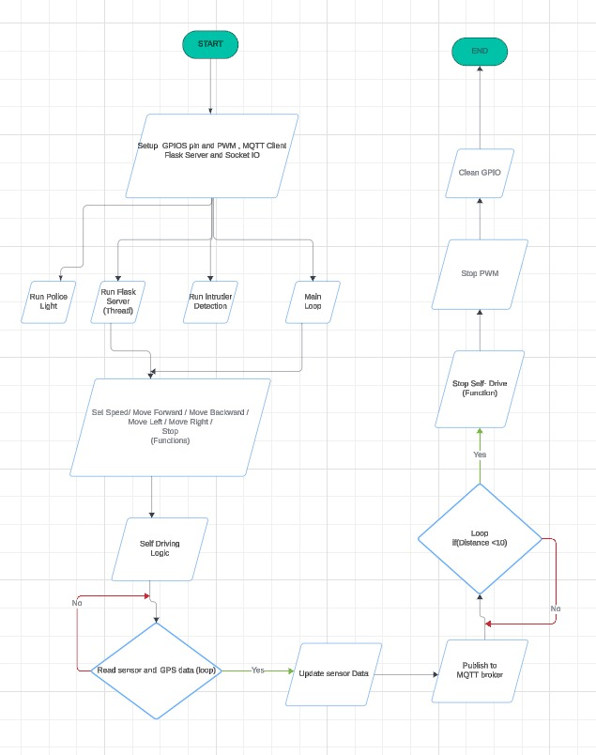

Figure 16: Flow Diagram
CHAPTER 6

COST ESTIMATION

S NO. | COMPONENTS | MRP
1 | RASPBERRY PI 4 | 7000
2 | ULTRASONIC SENSOR | 260
3 | MPU-9250 | 850
4 | METAL DETECTOR | 180
5 | DC MOTOR X2 | 150
6 | L298N | 200
7 | USB CAMERA | 750
8 | SERVO MOTOR | 640
9 | DHT 11 | 180
10 | ROBOTIC ARM | 980
11 | ESP 32 | 430
12 | NEO6M GPS | 360
13 | SOLDERING | 150
14 | JUMPER WIRE | 100
15 | PVC PIPE | 700
16 | NRF MODULE | 450
17 | PCB PLATE | 360
18 | BELT | 900
 | TOTAL | 14640

Table 3: Cost Estimation table
CHAPTER 7

CONCLUSION AND FUTURE SCOPE

7.1 RESULT
The implementation of an advanced surveillance robot, integrating AI, deep learning, and a suite of sophisticated sensors, has yielded significant enhancements in security and monitoring capabilities. This system includes intruder detection, a robotic arm, license plate recognition, metal detection, environmental sensors, and GPS, all of which have been rigorously tested to ensure high functionality and effectiveness. The intruder detection system, powered by advanced deep learning algorithms, demonstrated high accuracy in identifying unauthorized individuals, minimizing false alarms. The robotic arm extended the robot's utility by performing tasks such as opening doors and handling objects, crucial for scenarios requiring immediate intervention. License plate detection proved effective under various conditions, aiding in monitoring and identifying vehicles. Metal detection added a critical security layer by identifying concealed metallic objects. Environmental sensors provided valuable data on temperature and humidity, contributing to operational efficiency. GPS ensured precise location tracking and efficient navigation over large areas. Despite challenges such as high initial costs, data privacy concerns, and potential operational constraints in harsh conditions, the project's promising results underscore the significant potential of AI-driven robotic surveillance systems to transform security practices and enhance operational efficiency across various domains.

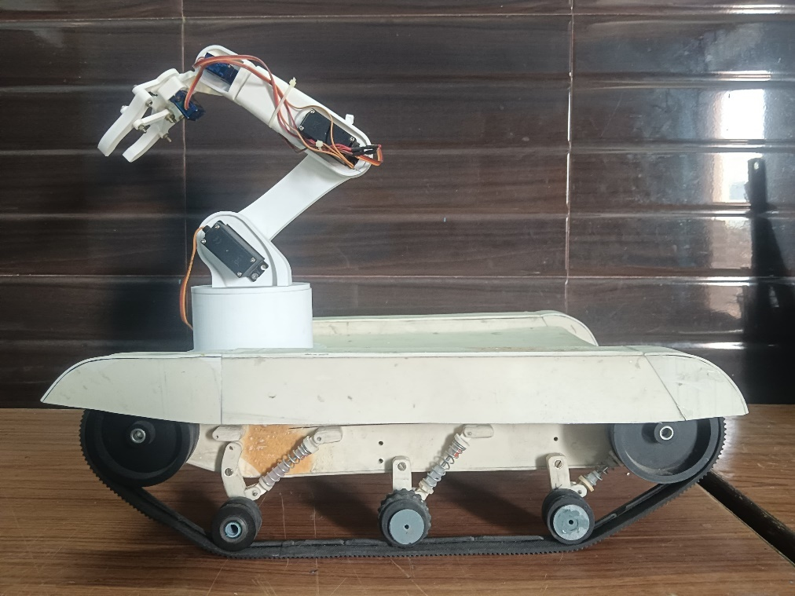

Figure 17: Final Project

7.2 ADVANTAGES
- Enhanced Security and Threat Detection: The advanced surveillance robot significantly improves security through its comprehensive threat detection capabilities. The integration of AI-powered intruder detection and metal detection ensures that unauthorized individuals and concealed threats are promptly identified, allowing for immediate response and reducing the risk of security breaches.
- Versatility and Multifunctionality: The inclusion of a robotic arm, license plate recognition, and environmental sensors makes the robot highly versatile. The robotic arm can perform a variety of tasks such as opening doors and handling objects, while the license plate recognition system aids in monitoring vehicular movements. Environmental sensors provide data on temperature and humidity, making the robot useful in diverse operational scenarios.
- Real-Time Monitoring and Immediate Response: Equipped with real-time processing capabilities, the robot can quickly detect and respond to security threats. This immediate reaction time is crucial for maintaining safety in sensitive areas, ensuring that any potential danger is addressed promptly and efficiently.
- Comprehensive Area Coverage and Navigation: The GPS integration allows for precise location tracking and efficient navigation, enabling the robot to cover large areas effectively. This capability is particularly beneficial for extensive facilities, industrial sites, and public spaces where thorough surveillance is required.
- Operational Efficiency and Data Collection: The robot's ability to continuously monitor and collect data on its environment, including temperature, humidity, and movement patterns, enhances operational efficiency. This data can be used to optimize security protocols, improve resource allocation, and support decision-making processes, ultimately leading to a more secure and well-managed environment.

7.3 LIMITATIONS
- High Initial Cost: The development and deployment of an advanced surveillance robot with integrated AI, sensors, and communication systems involve significant upfront costs. This can be a barrier for widespread adoption, especially for smaller organizations or in regions with limited financial resources.
- Data Privacy and Security Concerns: The extensive data collection and monitoring capabilities of the robot raise significant privacy and security concerns. Ensuring the secure handling, storage, and processing of sensitive data is crucial to prevent misuse, breaches, or unauthorized access. Addressing these concerns requires robust data protection measures and strict compliance with privacy regulations.
- Environmental and Operational Constraints: The robot's performance may be affected by harsh environmental conditions, such as extreme temperatures, heavy rain, or complex terrains. Additionally, its sensors and detection systems might have limitations in accuracy under certain conditions, such as poor lighting or crowded environments. These constraints can impact the robot's reliability and effectiveness in various scenarios, necessitating continuous improvements and adaptations.
7.4 FURTHER ENHANCEMENT AND FUTURE SCOPE
Future enhancements for this advanced surveillance robot include refining AI algorithms to improve detection and recognition accuracy, allowing for more precise and reliable identification of intruders and license plates. Advancements in autonomous decision-making will enable the robot to perform complex tasks without human intervention, increasing operational efficiency. Additionally, expanding the sensor suite to include specialized detectors, such as chemical or radiation sensors, will broaden the robot's applicability to more specialized and critical fields. Upgrading communication systems to incorporate technologies like 5G will ensure real-time data transmission and remote control over extended distances, enhancing its effectiveness in diverse environments.
The future scope of this project is vast, with potential applications extending beyond traditional security and surveillance. In critical infrastructure and industrial settings, the robot can be used for continuous monitoring and maintenance, ensuring safety and operational efficiency. In disaster response scenarios, the robot's capabilities can assist in search and rescue operations, environmental monitoring, and hazard detection. Furthermore, its use in public spaces for security and crowd management can significantly enhance public safety. As technology evolves, this surveillance robot could become an integral part of smart city initiatives, contributing to urban safety, traffic management, and emergency response systems, ultimately transforming how we approach security and surveillance.

7.5 CONCLUSION
The project on surveillance with artificial intelligence and remote control, utilizing an advanced deep learning robot, represents a significant advancement in security technology. Integrating features such as intruder detection, a robotic arm, license plate recognition, metal detection, and environmental sensors, the robot provides a comprehensive solution for diverse surveillance needs. This multifaceted approach ensures a robust and versatile system capable of addressing complex security challenges in real-time.
The inclusion of intruder detection and license plate recognition enhances the robot's ability to monitor and identify potential threats, ensuring a proactive security stance. The robotic arm adds a layer of interactivity, allowing the robot to perform tasks and manage objects, further extending its operational capabilities. Environmental monitoring through temperature and humidity sensors, coupled with metal detection, ensures a thorough assessment of the monitored area, adding depth to the robot's surveillance capabilities.
GPS integration is another critical component, enabling precise location tracking and efficient navigation. This feature not only aids in real-time monitoring but also ensures the robot can be deployed and managed effectively over large areas. The combination of these technologies highlights the robot's potential to transform surveillance practices, making it a valuable tool for securing critical infrastructure, public spaces, and industrial environments.
Looking ahead, there are exciting prospects for enhancing this technology. Improvements in AI algorithms can further refine detection accuracy, while advancements in autonomous decision-making will boost operational efficiency. Expanding the sensor suite to include specialized detectors and improving communication systems will broaden the robot's applicability. However, ethical considerations such as privacy, data security, and adherence to legal standards must be prioritized to ensure the responsible deployment of this powerful technology.

REFERENCES

1. Šabanović S. Robots in society, society in robots: Mutual shaping of society and technology as a framework for social robot design. Int J Soc Robot. 2010;2(4):439–50.
2. Ingrand F, Ghallab M. Robotics and artificial intelligence: A perspective on deliberation functions. AI Commun. 2014;27(1):63–80.
3. Kamran S, Farhat I, Talha Mahboob A, Gagandeep Kaur A, Liton D, Abdul Ghaffar K, et al. The Impact of Artificial intelligence and Robotics on the Future Employment Opportunities. Trends Comput Sci Inf Technol. 2020;5:050–4.
4. Chung J, Lee YS. The evolving impact of robots on jobs. ILR Rev. 2023;76(2):290–319.
5. De Vries GJ, Gentile E, Miroudot S, Wacker KM. The rise of robots and the fall of routine jobs. Labour Econ. 2020;66:101885.
6. Lewicki P, Tochowicz J, van Genuchten J. Are robots taking our jobs? A RoboPlatform at a bank. IEEE Softw. 2019;36(3):101–4.
7. Niemueller T, Widyadharma S. Artificial intelligence–an introduction to robotics. Reason about Namin Syst. 2003;
8. Alam TM, Awan MJ. Domain analysis of information extraction techniques. Int J Multidiscip Sci Eng. 2018;9(6).
9. Alam TM, Shaukat K, Mushtaq M, Ali Y, Khushi M, Luo S, et al. Corporate bankruptcy prediction: An approach towards better corporate world. Comput J. 2021;64(11):1731–46.
10. Latif MZ, Shaukat K, Luo S, Hameed IA, Iqbal F, Alam TM. Risk factors identification of malignant mesothelioma: A data mining based approach. In: 2020 International Conference on Electrical, Communication, and Computer Engineering (ICECCE). IEEE; 2020. p. 1–6.
11. Halfacree G, Upton E. Raspberry Pi user guide. John Wiley & Sons; 2012.
12. Sivasoundari A, Kalaimani S, Balamurugan M. Wireless Surveillance Robot with Motion Detection and Live Video Transmission. 2013;(6):14–22.
13. Pi R. Surveillance Robot with Face Recognition using. 2019;8(12):648–52.
14. Frp XJ, Frp VMJ, Frp SPJ, Duhd O, Lv LW, Frvw D, et al. 9 8Vkd 5Dql. 6859:5–9.
15. Papers C. CONCEPT PAPERS WIFIREBOT : SMART ESP32 BASED SURVEILLANCE CAR. 2024;12(1).
16. Abdullah-Al-Noman M, Eva AN, Yeahyea TB, Khan R. Computer Vision-based Robotic Arm for Object Color, Shape, and Size Detection. J Robot Control. 2022;3(2):180–6.
17. Saha S, Singh A, Bera P, Kamal MN, Dutta S, Gorian U, et al. GPS based smart spy surveillance robotic system using Raspberry Pi for security application and remote sensing. 2017 8th IEEE Annu Inf Technol Electron Mob Commun Conf IEMCON 2017. 2017;705–9.
18. Meghana S, Nikhil T V., Murali R, Sanjana S, Vidhya R, Mohammed KJ. Design and implementation of surveillance robot for outdoor security. RTEICT 2017 - 2nd IEEE Int Conf Recent Trends Electron Inf Commun Technol Proc. 2017;2018-January:1679–82.
19. Bp S, Suhas G, Sushma S, Prasad SH, S SB. Turkish Journal of Computer and Mathematics Education Research Article Surveillance Spy Robot with Wireless Night Vision Camera and Metal Detection Research Article. 2021;12(12):2397–402.

